
Insert Facility/Institute Logo Here
STANDARD OPERATING PROCEDURE (SOP) TEMPLATE
Facility:

SOP Title: Securing Assets During Emergency Situations

Document Number: | Version Number: 00  Effective Date: MM-DD-YYYY
Other documents cross-referenced in this SOP (i.e., manuals, SOPs, forms, records):
Incident Response Program Plan
Appendix 1: Pathogen Prioritization
Appendix 2: Security Tiering System
Appendix 3: Risk Assessment Diagram
Information Security Program Plan
Chemical Inactivation of Pathogens SOP
Incinerator Operation SOP
Autoclave Operation and Maintenance SOP

Revision Number | Sections Changed | Description of Change | Date | Approved By
INSTRUCTIONS: The Biorisk Management Manual and supporting Standard Operating Procedure (SOP) templates provide a general overview of common considerations and information that should be addressed within a biorisk management system and program. These templates are not exhaustive, and facilities must customize each document to ensure it is locally applicable and relevant.
- Black text can be considered generic text which may be appropriate for inclusion in a facility’s biorisk management manual and SOPs.
- Red text should be considered guidance or examples and must be reviewed and replaced with facility-specific information.

- Purpose
The purpose of this SOP is to provide procedures that describe enhanced security measures applicable to emergency laboratory biosecurity threats and incidents. The procedures will be used by Insert Institute/Facility Name when information pertaining to a biosecurity threat is identified. This SOP is designed to secure materials and equipment that could be used maliciously and prevent unauthorized release. It describes procedures to protect biosecurity relevant materials (see WHO guidance) from adversaries. An adversary is a person(s) with potential intent, motive, and means to use a biohazard to cause harm. Some materials may require inactivation or destruction as the security level increases.
- Scope
This document applies to all facility personnel, students, contractors, and visitors within Insert Institute/Facility Name and is used when information pertaining to a laboratory biosecurity threat or incident has been identified.
- Responsibilities
- Emergency Manager
  - Identify resources (human and financial) required to implement this procedure
  - Develop and submit budget request (annually or otherwise) based on identified resources required
  - Allocate resources appropriately to implement this procedure
  - Establish, implement, and update this procedure
  - Coordinate required materials and equipment are properly selected, located, operated, and maintained
  - Facilitate agreements necessary to coordinate with local emergency, fire, and first response entities
  - Identify emergency service entities and document and update contact information
  - Coordinate, schedule, and budget staff training on this procedure, including periodic drills and exercises
  - Lead/Participate in the risk assessment team
  - Oversee emergency operations and directs procedures
  - Coordinate with Scientific Manager/Director and Security Manager
  - Decide tier level, with consultation with Security Manager and Scientific Manager/Director
  - Notify members of the workforce of tier level (may delegate notification to trusted pre-defined personnel)
  - Receive and consolidate reports from facility/laboratory personnel
- Scientific Manager/Director
  - Provide resources (human and financial) to implement enhanced security measures to protect identified materials, agents, biosecurity relevant equipment (see WHO guidance), information, computer systems, security systems and list any additional items requiring security against biosecurity threats
  - Evaluate responses and implement corrective actions to prevent future incidents and promote continual improvement of the biorisk management system
  - Coordinate with Emergency Manager and Security Manager to determine which tiered scenario to implement in accordance with this procedure
  - Define biosecurity relevant material in coordination with Designated Supervisors/Information and Communications/Telecommunications Technology (ICT) / Selected Facility Personnel
  - Support risk assessment team with relevant expertise
  - Communicate this procedure to facility personnel, staff, students, and visitors
  - Assign Designated Response Personnel
  - Reports to Emergency Manager
- Security Manager
  - Provide expertise on effective and proportionate enhanced security measures as part of the risk assessment team
  - Communicate and coordinate with outside emergency services and response forces during an incident
  - Coordinate with Emergency Manager and Scientific Manager/Director to determine which tiered scenario to implement in accordance with this procedure
  - Deploy Authorized Security Personnel /Guard Force to evaluate the incident (or evaluate incident themselves)
  - Reports to Emergency Manager
- Authorized Security Personnel / Guard Force (or Security Manager/Officer assumes responsibilities)
  - Assess potential biosecurity threats to determine validity of notification/alert and the level of action required (e.g. credible, real, hoax)
  - Characterize current threat and evaluate likelihood of an incident occurring to determine appropriate tiered response (see Appendix 1: Security Tiering System)
  - Implement enhanced security measures including testing and monitoring equipment
  - Support risk assessment team with relevant expertise
- Information and Communications/Telecommunications Technology (ICT Personnel) / Selected Facility Personnel
  - Provide expertise on effective and proportionate enhanced security for sensitive or biosecurity relevant information as part of the risk assessment team
  - Obtain resources (human, equipment, storage locations etc.) needed to implement this procedure
  - Implement enhanced security measures within this protocol, including testing and monitoring software and equipment
  - Assign human resources to implement enhanced security measures to protect identified materials, agents, biosecurity relevant equipment, information, computer systems, security systems etc. against biosecurity threats
  - Support risk assessment team with relevant expertise
- Designated Response Personnel
  - Support risk assessment team with relevant expertise to identify materials for inactivation
  - Implement tier level response per tier plan (see Appendix 1: Security Tiering System) per security notification
  - Report status to Emergency Manager
- Supervisor
  - Coordinate with facility staff at the department/division level
  - Report to Scientific Manager/Director
- Designated Supervisors (a smaller subset of Supervisors)
  - Support risk assessment team with relevant expertise to identify materials for inactivation
  - Oversee designated response personnel and assist with tier level response
  - Report to Scientific Manager/Director during incident response
- Members of the Workforce (MOW)
  - Report security issues to Emergency Manager and/or Scientific Manager/Director
  - Cooperate with investigations and implement actions as required in this procedure
  - Support risk assessment team with relevant expertise
- Essential Personnel
  - List personnel who are authorized to continue to work on site when laboratory access is restricted due to biosecurity threat
- Preparation (Anything that needs to be in place prior to commencing the procedure)
  - Materials
- Biosecurity relevant material (as defined by the Scientific Manager/Director such as biological agents, nucleic acids, synthetically derived biohazardous material, laboratory devices, software and data)
- Disinfectants (such as 5.25% sodium hypochlorite solution based on agent-specific risk assessment)
- PPE as determined by risk assessment
- Bags, boxes, biohazardous waste bags etc. to place materials inside prior to autoclaving, incinerating, shredding
  - Equipment
- Computers (if using electronic database)
- Access control hardware (e.g., locks, lockable doors, lockable windows, fencing)
- Access control software (e.g., access keypads, Radio-frequency identification (RFID))
- Personnel identification linked to permission to access the facility
- Visitor Identification
- Detection systems
- Surveillance capability (e.g., reception desk, video recording)
- Communication system
- Incinerator, type, model
- Autoclave, size, type and model
- Bins/trays for disinfection
- Tools used to destroy electronics (e.g., degaussing, steel mallet, industrial grade shredder, plastics shredder, hard drive reset or sanitizer, oxy-acetylene torch)
- Lockable file cabinet to secure information to be physically moved or destroyed)
- Paper shredder
  - Records and forms
- Materials deemed sensitive as per Information Security Program Plan (e.g., inventory of biosecurity relevant material; comprehensive risk assessment for pathogens stored at Insert Institute/Facility Name; emergency contact roster; audits that identify biosecurity relevant materials)

- Procedure (Actions: What steps must be taken to move from the input to the output?)
All Facility Personnel (including management, security personnel, computer staff, laboratory staff, administrative staff) will report a potential biosecurity incident to Security Manager/Officer.
Note: Security Manager/Officer may identify a potential biosecurity threat and initiate this procedure.

Notification of Potential Threat

  - Security Manager or Facility authorized personnel Security Officer/Guard Force/authorized personnel identifies or receives a security threat by trusted source (external or internal to facility) and initiates this procedure
  - Security Manager assesses the validity of the threat
  - If deemed not valid, notifies (by email, memo, text) the Emergency Manager within specified time (4 h, 24 h, 48 h 7 days), documents the assessment and ends the procedure.
  - If deemed valid, notifies (by phone) the Emergency Manager and Scientific Manager/Director immediately.
  - Emergency Manager and Scientific Manager/Director consult with Security Manager (and additional delegated staff as needed) to determine validity of the threat and which Security response tier level to initiate. See Appendix 1: Security Tiering System for guidance.
Note: Security Manager may coordinate with delegated roles within an institute to facilitate notification to all members of the workforce. Delegated roles such as designated response personnel shall be delineated ahead of time and contact list be updated regularly. Additionally, visitors shall have an assigned responsible facility/laboratory staff member, the staff member will be responsible to inform the visitor of applicable actions.

Tier 1: Enhanced Security
Note: this tier requires the facility to have pre-planned and prepared for enhanced security including exercises to practice the plan and validate responsibilities. See appendix 1 and 2 for guidance on planning and preparations.
If adversary enters Insert Institute/Facility Name, jump to Tier 5: Critical Life Safety

- Emergency Manager Initiate Tier 1: Enhanced Security with a quiet broad notification (text, email, phone to designated personnel, signage)

Example Notification

***Tier 1: Enhanced Security***
Authorized Security Personnel – initiate tier 1 security protocols.
Designated Response Personnel – verify Security Measures are in Place & Report to Security Manager (or delegate)
ICT Personnel – initiate tier 1 security protocols
Members of the Workforce – notify supervisor of any security situation
Work may continue

- Designated Response Personnel monitor locations with designated materials, secure information and report status to Emergency Manager. Remain situationally aware, report of normal events to Emergency Manager by (text, phone, email). Be ready for potential escalation of security situation.
- Supervisors and Designated Supervisors report security situations and reports collected from staff to Emergency Manager.
- Authorized Security Personnel (security guards) (or designated staff) lock entry and exit gates, building doors, security zones; increase personnel checks at entrances (campus, buildings, security zones; increase patrol frequency and or quantity; verify and monitor security measures are in place and operating correctly (e.g., access controls, cameras, sensors, doors are closed and locked).
- ICT Personnel monitor electronic systems for infiltration, ensure backups are up to date and secured (preferably offsite). Perform network checks, check firewall, security scans, update encryption and anti-virus software.
- Security Manager secure the guard house and central alarm system (CAS). Monitor situation and notify Emergency Manager of status and potential for increased security tier.
- Emergency Manager brief Scientific Manager/Director and Security Manager with updates and notifications. Coordinates with Security Manager and Scientific Manager/Director to monitor security/threat situation for evaluation against security tier level to raise the tier level or downgrade the tier level. Receives reports from MOW, Supervisors, Scientific Manager/Director, and Security Manager.
- Scientific Manager/Director communicate reports from staff to Emergency Manager and updates Emergency Manager as needed.
- Scientific Manager/Director coordinate with Emergency Manager and personnel within this procedure to enhance security awareness.
- Closing and locking doors to laboratory buildings, pathogen storage, ICT, inventory records, animal housing, and specific rooms and equipment containing sensitive biosecurity material
- Members of the Workforce follow instructions from Scientific Manager/Director, Supervisor, and security personnel. Report off normal events to Supervisor or Emergency Manager.

Tier 2: Heightened Security
Note: this tier requires the facility to have pre-planned and prepared for rapid deployment of heightened and hardened security measures with clear responsibilities. The preparation should include exercises to practice the plans and validate preparedness and staged equipment for rapid deployment. See appendix 1 and 2 for guidance on planning and preparations.
If adversary enters Insert Institute/Facility Name, jump to Tier 5: Critical Life Safety

- Emergency Manager Initiate Tier 2: Heighten & Harden Security with a quiet broad notification (text, email, phone to designated personnel, signage) or with
overt notification (public announcement system, designated personnel verbally)

Example Notification

***Tier 2: Heighten & Harden Security***
Authorized Security Personnel – Initiate Tier 2: Hardened Security measures
Designated Response Personnel & Supervisors– initiate Tier 2: Hardened Security measures.
ICT Personnel – initiate tier 2 security measures.
Members of the workforce -
Non-essential personnel and visitors depart the facility. Report any security issues to Security or Scientific Managers.
Essential personnel follow Supervisor’s directions.

- Designated Response Personnel complete actions from tier 1 and heighten and harden security at specified locations per tier 2 plan.
- Supervisors coordinate the following:
- Non-essential personnel and visitors secure areas (if safe) and depart the facility per tier 2 plan.
- Essential personnel may continue work once facility security is hardened per tier 2 plan.
- Communicate with Emergency Manager and Security Manager regarding security status per tier 2 plan.
- Authorized Security Personnel (Security Guards) conduct the following steps:
- Limit personnel on site/campus and assist visitors and non-essential personnel to depart campus safely. Note: non-essential personnel and visitors may not return to the campus until notified.
- Heighten and harden security at specified locations per tier 2 plan. List and describe heightened and hardened security. [Secure entrance gates (describe how the gate will be secured to prevent access such as emergency barricades (planters, equipment, vehicles, spike strips, addition of chains and padlocks) and when the gate will be secured (after or during evacuation of non-essential personnel). Deploy to hardened lookout locations to observe adversarial threat.]
- Monitor security situation with regularly communications to the Security Manager per tier 2 Plan.
- ICT Personnel limit access to internet and intranet from within the facility and external to the facility. Apply enhanced security measures to laptop and desktop computers, servers, hard drives per tier 2 plan (update passwords, increase frequency of scans).
- Security Manager monitor progress towards enhance security posture deploy additional authorized security personnel or designated personnel to harden security measures as needed. Monitor ongoing situation, notify Emergency Manager of status and potential increased security/threat situation for evaluation against security tier level to raise or lower the tier.
- Emergency Manager brief Security Manager and Scientific Manager/Director with updates and notifications. Coordinates with Security Manager to monitor security/threat situation for evaluation against security tier level to raise the tier level or downgrade the tier level. Receives reports from MOW, Supervisors, Scientific Manager/Director, and Security Manager.
- Scientific Manager/Director communicate reports from staff to Emergency Manager and updates Emergency Manager as needed.
- Scientific Manager/Director coordinate with personnel within this procedure to harden security measures.
- Exclude visitors and non-essential personnel from laboratories.
- Verify biosecurity relevant assets are secured (e.g. secure laboratory access points, freezer locks, computer and laboratory workstations left unattended, sensitive information including inventories, lab notes).
- Members of the Workforce follow instructions from Supervisor, Scientific Manager/Director, and authorized security personnel.
- Non-essential personnel – shutdown work, secure workstations (if safe), depart facility. Escort visitors off the campus.
- Essential personnel – may continue work per Supervisor’s direction or when tier 2 hardened security measures are implemented.

Tier 3: Organized Withdrawal
Note: this tier requires the facility to have pre-planned and prepared for withdrawal and rendering equipment non-operational. The preparation should include exercises to practice the plans and validate preparedness and staged withdrawal and transfer of biosecurity materials (samples, hard drives, etc.) and rendering equipment (laboratory equipment, servers, computers, etc.) non-operational. See appendix 1 and 2 for guidance on planning and preparations.
If adversary enters Insert Institute/Facility Name, jump to Tier 5: Critical Life Safety
- Emergency Manager initiate Tier 3: Organized Withdrawal and render materials non-operational with a quiet broad notification (text, email, phone to designated personnel, signage) or with overt notification (public announcement system, designated personnel verbally)

Example Notification

***Tier 3: Organize Withdrawal and render materials non-operational ***
Authorized Security Personnel – initiate tier 3 Security measures
Designated Response Personnel & Designated Supervisors– initiate tier 3 Withdrawal & render materials non-operational
ICT Personnel – initiate tier 3 Security measures
Members of the workforce - stop all work, vacate premises.
Only designated personnel allowed to remain per tier 3 plan.

- Designated Response Personnel render specified laboratory equipment and computers non-operational per tier 3 plan (Remove or damage gloves from BSC III, specify equipment for fuse removal, specify equipment to unplug). Transfer of pre-selected specified biosecurity materials (samples, hard drives, etc.) to pre-determined safe location per tier 3 plan. Follow Designated Supervisor's directions to leave site or further assist activities.
- Supervisors follow Designated Supervisor's directions to leave site or assist activities.
- Designated Supervisors coordinate the following:
- Non-essential work and staff secure workstations and leave the campus, provide directions per tier 3 plan.
- Essential personnel stop work and either depart the facility or assist per tier 3 plan.
- Communicate with Emergency Manager regarding security status per tier 3 plan.
- Follow Designated Supervisor's directions to leave site or further assist activities.
- Authorized Security Personnel (Security Guards) conduct the following steps:
- Limit personnel on site/campus and assist visitors and non-essential personnel to depart campus safely.
Note: personnel and visitors may not return to the campus until notified.
- Heighten and harden security at specified locations per tier 3 plan
    - List and describe enhanced delay measures not used during normal operations such as barricading doors with large furniture/equipment, adding crossbars to the doors (can be screwed into the door frame if there are not fixtures for holding a crossbar), chaining/padlocking doors, or screwing doors into their frames. Ensure egress plans are considered when planning what doors can be secured with what methods. Also consider protecting exterior windows with plywood, metal sheeting, or similar materials and removing or securing any equipment outside of the building that could be used by an adversary (e.g., tools, ladders, heavy machinery). Consider disabling any vehicles on site that won’t be used in evacuation by disconnecting fuel lines, removing fuses or batteries, etc.). Soap could be used in unused corridors to make it more difficult for adversaries to travel through.
- Monitor security situation with regular communications to the Security Manager per tier 3 plan.
- ICT Personnel shut down internet and intranet. Transfer pre-selected computers, hard drives etc. to safe location (add location). Render pre-selected computers, hard drives, servers non-operational. Harden network access, enact enhanced restrictions that limit network access to selected personnel (e.g., ICT and management staff only). Follow Designated Supervisor's directions to leave site or further assist activities.
- Emergency Manager coordinate with Scientific Manager/Director to securely transfer biosecurity materials and render equipment non-operational. Monitor and communicate with Authorized Security Personnel (Security Guards) and Security Manager for changes in threat situation. Monitor ongoing situation, notify Scientific Manager/Director of status and potential increased security/threat situation for evaluation against security tier level to raise or lower the tier. Follow Designated Supervisor's directions to leave site or further assist activities.
- Security Manager liaise with outside responders/law enforcement as needed per Incident Response Program Plan and update Emergency Manager as needed.
- Scientific Manager/Director communicate reports from staff to Emergency Manager and update Emergency Manager as needed.
- Scientific Manager/Director coordinate with personnel within this procedure to securely move pre-selected biosecurity materials and render equipment non-operational. Communicate with outside responders/law enforcement as needed per Incident Response Program Plan. Follow Designated Supervisor's directions to leave site or further assist activities.
- Members of the Workforce cease all work. Secure workstation and biosecurity relevant materials per tier 3 plan and follow Designated Supervisor's directions to leave site or assist activities.

Tier 4: Inactivate & Destroy
Note: this tier requires the facility to have pre-planned and prepared for inactivation and destruction of pre-identified biosecurity related materials (samples, equipment, computers, etc.) The preparation should include staged tools and equipment to inactivate or destroy materials. See appendix 1 and 2 for guidance on planning and preparations. Inactivation/Destruction is an irreversible step, but samples/cells/stocks can be re-stocked if the threat subsides, and the facility is able to restore normal conditions/functions. Complete this step when the threat is verified and significant.
If adversary enters Insert Institute/Facility Name, jump to Tier 5: Critical Life Safety

- Emergency Manager Initiate Tier 4: Inactivate & Destroy with a quiet broad notification (text, email, phone to designated personnel, signage) or with overt notification (public announcement system, designated personnel verbally)

Example Notification

***Tier 4: Inactivate & Destroy***
Authorized Security Personnel – initiate tier 4 security measures
Designated Response Personnel & Designated Supervisors– initiate Tier 4: Inactivate & Destroy
ICT Personnel – initiate tier 4 security measures
Members of the Workforce - stop all work, vacate premises.
Only designated personnel allowed to remain per tier 4 plan.

- Designated Response Personnel inactivate and destroy biosecurity relevant materials according to prioritization chart in Appendix 1: Security Tiering System per tier 4 plan. Report status to designated person (Emergency Manager) when safe. Leave the site if possible or hide if in danger.
- Permanent inactivation/disablement of equipment so that it appears non-functional (break glove attachments from BSC III and destroy filters, filter attachment points, and airflow controls, cut power to freezer compressors and damage freezer door frames)
- Optional: Evacuate unexposed/uninfected animals if resources are available to relocate and transport animals to an offsite location
    - Describe 1) which animals will be relocated; 2) who will transport animals; 3) how animals will be transported; 4) where animals will be taken.
- If the facility conducts animal experiments/ challenges, depopulate and properly dispose of infected/exposed animals
- Describe which animals will be depopulated (e.g. animals exposed to or infected with biosecurity relevant materials, all animals, animals located in vulnerable locations)
- Describe how animals will be depopulated. The process must be simple and consider 1) available resources; 2) availability of power and fuel; 3) technical ability of designated staff to conduct this activity; 4) remaining time before adversary is expected to be at [Insert Institute/Facility Name]; and 5) pathogen characteristics that define appropriate decontamination methods.
- Describe procedures to dispose of animals (e.g. incineration, burning, burial)
  - Leave site and account for personnel when safe per tier 4 plan.

[Enter a table with pathogen name, decontamination method, time requirements, other requirements.]

- Designated Supervisors oversee and assist with inactivation and destruction of biosecurity materials per tier 4 plan. Report status to Emergency Manager when safe. Leave site and account for personnel when safe per tier 4 plan.
- Supervisors leave site and account for personnel when safe per tier 4 plan.
- Authorized Security Personnel (Security Guards) harden security posture per tier 3 and tier 4 plans to allow Designated Response Personnel to complete their tasks. Take position at hardened secured locations to safely observe movement of adversarial threats; alert staff to threats per tier 4 plan; communicate with Security Manager threat situation and receive directions. Support outside responders/law enforcement per tier 4 plan.
- ICT Personnel destroy specified computers, hard drives, servers per tier 3 plan.
- Networking Devices and office equipment
- Clear devices with a full manufacturer’s reset to reset the router, switch, hubs, repeaters, and/or bridges back to its factory default settings. Magnetic destruction (degaussing), define and initiate Secure Erase sequence, overwriting existing data on a hard drive with random strings of characters, physical destruction of hard drive (manually dissemble computer and destroy hard drive by scratching disc and smashing to bits with a steel mallet), crushing/milling (crush, grind, and pulverize into small pieces), shredding (industrial grade shredder, plastics shredder), data sanitization (overwrite existing data on a hard drive with random strings of characters). Incineration or use an oxy-acetylene torch to melt the hard drive down to a puddle can be used as a last resort if resources are available, consideration should be given to personal injury and health and/or environmental risks because proper PPE should be used to prevent burns and laboratory equipment/computer may contain toxic chemicals and/or heavy metals (e.g., lead, mercury, cadmium). Drives, operating systems, applications, and user files could also be protected using full-disk encryption to secure ensure they cannot be accessed without a key, the encryption key should be destroyed.
NOTE: Network Devices may contain removable storage. The removable media must be removed and sanitized using media-specific techniques.
- Hard copies of sensitive data/information
- Destroy paper using crosscut shredders which produce particles that are 1 mm x 5 mm (0.04 in. x 0.2 in.) in size (or smaller) or pulverize/disintegrate paper materials using disintegrator devices equipped with a 3/32 in. (2.4 mm) security screen. Destroy microforms (microfilm, microfiche, or other reduced image photo negatives) by burning.
- Laboratory devices (e.g. Sequencers, Instruments, Lab Computers)
- Clear with full manufacturer’s reset to reset the office equipment to its factory default settings. Disable credentials supporting the instrument (service account, API tokens, software, etc.). Removing memory, hard drives, attached/external memory and all computing boards. Shredding, disintegrating, or pulverizing to destroy computing boards. Incineration to burn computing boards or destruction by autoclaving parts that touched samples can be considered as a last resort if resources are available, consideration should be given to health and/or environmental risks because laboratory equipment/computer may contain toxic chemicals and/or heavy metals (e.g., lead, mercury, cadmium).
- Leave site and account for personnel when safe per tier 4 plan.
- Security Manager coordinate personnel within this procedure to render inactive designated biosecurity materials and information. Monitor and communicate with Authorized Security Personnel (Security Guards) to harden security to allow designated response personnel to complete their tasks and to observe and detect adversarial threats. Notify and coordinate with Emergency Manager on threat situation and outside responders/law enforcement.
- Scientific Manager/Director coordinate with Emergency Manager and personnel within this procedure to inactivate and destroy biosecurity materials per tier 4 plan. Leave site and account for personnel when safe per tier 4 plan.
- Emergency Manager Coordinate with Scientific Manager/Director and Security Manager on threat situation and outside responders/law enforcement. Leave site and account for personnel when safe per tier 4 plan.
- Members of the Workforce place biosecurity related materials in designated inactivation locations. Leave site and report when safe per tier 4 plan.

Tier 5: Critical Life Safety
Note: this tier is for situations that may turn life threatening, it requires all staff to run or hide (fight as a last resort only) to save one’s life and assist others if possible. The preparation should include identified hardened locations to hide and routes to escape. See appendix 1 and 2 for guidance on planning and preparations.

- Emergency Manager Initiate Tier 5: Critical Life Safety with a quiet broad notification (text, email, phone to designated personnel, signage) or with overt notification (public announcement system, designated personnel verbally)

Example Notification

***Tier 5: Critical Life Safety***
All Personnel - Run or hide per Tier 5: Critical Safety plan
Stop all work.
Evacuate site if safe. Hide if in danger.

- Designated Response Personnel leave the site if safe or hide if in danger.
Supervisors & Designated Supervisors leave the site if safe or hide if in danger.
Authorized Security Personnel (Security Guards) leave the site if safe or hide if in danger.
ICT Personnel leave the site if safe or hide if in danger.
Security Manager leave the site if safe or hide if in danger.
Emergency Manager leave the site if safe or hide if in danger.
Scientific Manager/Director leave the site if safe or hide if in danger.
Members of the Workforce leave the site if safe or hide if in danger.

Follow run/hide/fight guidance: https://www.fema.gov/sites/default/files/2020-10/fema_scenario_1_active_shooter_TTX_answer_key-01102020.pdf

- References
  - World Health Organisation (WHO), Biorisk Management: Laboratory Biosecurity Guidance, 21 June 2024, https://www.who.int/publications/i/item/9789240095113
  - https://www.fema.gov/sites/default/files/2020-10/fema_scenario_1_active_shooter_TTX_answer_key-01102020.pdf
  - World Health Organisation (WHO), 2020, Laboratory Biosafety Manual, 4th Edition, https://www.who.int/publications/i/item/9789240011311

- Appendices
  - Appendix 1: Security Tiering System
  - Appendix 2: Pathogen Prioritization
  - Appendix 3: Risk Assessment Diagram

Appendix 1: Security Tiering System
- Purpose
The purpose of this process is to provide guidance for establishing a tiering system to define tier levels when using the Securing Assets During Emergency Situations SOP. This process will be used by Insert Institute/Facility Name to establish security tiers that are activated when information pertaining to a biosecurity threat is identified to prevent malicious use of pathogens, equipment, and data.
- A tiering system will be established by Insert Institute/Facility Name to determine security levels that guide facility operations during emergency situations.

  - Follow the steps in Appendix 3: Risk Assessment Diagram to assess the risk of biosecurity threats in a variety of situations. Identify threats, hazards, and describe work activities to outline assets, adversaries, and vulnerabilities. Define potential scenarios and characterize risk associated with each. Determine the number of security tiers needed (example: Tier 1: Enhanced Security, Tier 2: Heightened Security, Tier 3: Organized Withdrawal, Tier 4: Inactivate and Destroy, Tier 5: Critical Life safety) and match scenarios to security tier levels.
Tier 1 – Biosecurity risk assessment determines likelihood of unauthorized access and release is low and indicates baseline physical and cyber security mitigation measures. Verify mitigation measures are in place by increasing monitoring of security components and systems to ensure they are functioning properly. This tier may include adding mitigation measures that would enhance security, including verifying identification of visitors and increasing patrols. Work may continue. All members of the workforce remain on campus.
Example scenarios: Observed or notified by reliable source that a nearby protest is planned; Increased theft in the area
Tier 2 – Biosecurity risk assessment determines likelihood of unauthorized access and release is low to moderate and indicates heightened and hardened physical and cyber security mitigation measures above the baseline of tier 1. Hardening physical and cyber security components and systems are implemented to increase delay and improve detection of potential adversaries. Information is received that indicates adversarial threats are in the region and likelihood of biosecurity incident is higher than tier 1. Essential work may continue. Only essential personnel are on the campus for essential laboratory work.
Example scenarios: Observed or notified by reliable source that protestors may target facility; Increased theft on facility campus
Tier 3 – Biosecurity risk assessment determines likelihood of unauthorized access and release is moderate to high with higher likelihood of biosecurity incident to occur than tier 2 and indicates an organized withdrawal. Further hardening physical and cyber security components and systems to substantially delay threats while designated staff withdraw pre-determined biosecurity materials, information and computers and render equipment and computers non-operational. All work stops to respond to tier 3 security situation. Ideally, only designated response related personnel remain on the campus.
Example scenarios: Observed or notified by reliable source that protestors plan or express intent to enter facility; Political situation disrupts continuity of standard government operations
Tier 4 – Biosecurity risk assessment determines likelihood of unauthorized access and release is very high and indicates inactivation and destruction of biosecurity relevant materials. Imminent threat drives response to inactivate and destroy pre-determined biosecurity materials, information, equipment and computers. All work stops to respond to tier 4 security situation. Ideally, only designated response related personnel remain on the campus.
Example scenarios: Observed or notified by reliable source that an adversary plans to obtain assets from the facility; Political power seized by group that has recent or past history of biological weapons development
Tier 5 – Life safety risks drive tier 5.
Example scenario: Adversary enters the facility’s campus

  - Management and leadership coordinate with security (and additional delegated staff as needed) to determine validity of threat and decide on security tier level, commensurate with security and threat risk. Ongoing situations are closely monitored to determine if additional security measures are required.

The following are considerations for increasing security posture and tier level based on the security situation and biosecurity risk of assets and information:
    - Ongoing observations or notifications from credible and reliable sources
    - Changing political situations reported by credible news sources
    - Threats called in to the facility
    - Adversary contacts member(s) of the workforce
    - Adversary visually present on facility campus
    - Consultation with outside responders / law enforcement
Appendix 2: Asset Prioritization
- Purpose
The purpose of this process is to prevent malicious use of high-consequence material pathogens, equipment, and data. It is intended to be used by Insert Institute/Facility Name to identify and prioritize high-consequence material for destruction according to the Securing Assets During Emergency Situations SOP when a high-level biosecurity threat is identified (Appendix 1: Security Tiering System). This process results in a rank ordered list of high-consequence material to inform order of inactivation/destruction.

- Determine consequences of unauthorized release of high-consequence materials according to the WHO Biosecurity Guidance: Annex 1 Biosecurity risk assessment template, assuming access already occurred. Consider all forms of high-consequence materials separately (biological materials, equipment, and data/information including printed materials on paper).
  - Identify high-consequence materials considering quantity and form.
    - Biological materials (e.g., isolate, diagnostic specimen, PCR product, infected animals)
    - Equipment (e.g., biosecurity relevant, cold storage, data storage, computer, incubator)
    - Data/information (e.g., inventory, genetic/genomic sequence, intranet, cloud-based storage, laboratory procedures, results and research, architecture, risk assessments)
  - Classify potential consequences as per WHO Biosecurity Guidance: Table A1.1. Actions are defined in Appendix 1: Security Tiering System below.

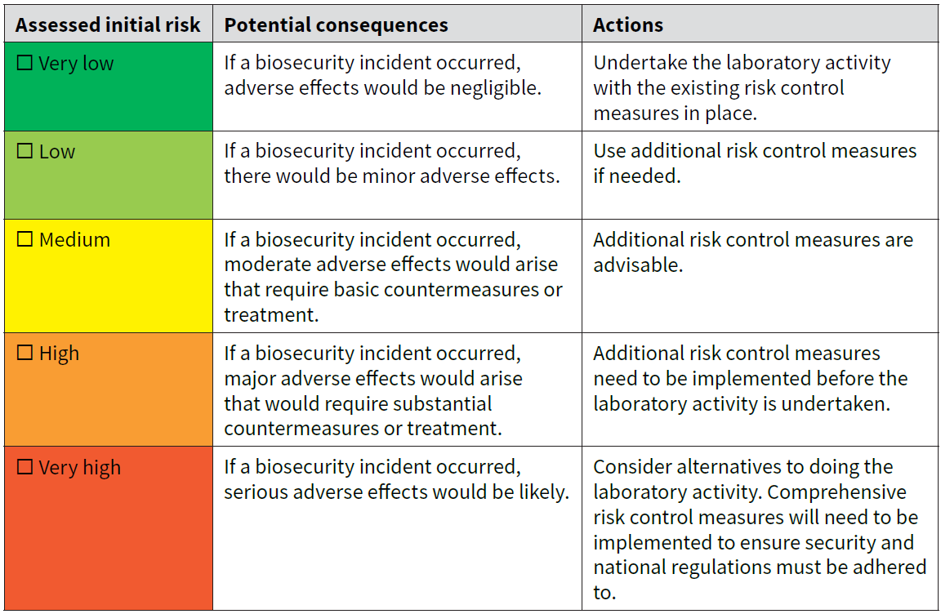

Assign a value to the consequence if an exposure and/or release occurred?
- Negligible (Very low): Adverse effects would be negligible.
- Minor (Low): There would be minor adverse effects or Incident with self-limiting consequences
- Moderate (Medium): moderate adverse effects would arise that require basic countermeasures or treatment or Incident that requires medical treatment and/or has insignificant environmental consequences
- Major (High): major adverse effects would arise that would require substantial countermeasures or treatment or Incident with potential lost time due to infection but non-permanent consequence and/or limited environmental impact.
- Severe (Very high): serious adverse effects would be likely or Incident with potential lost time due to infection, permanent, impairing harm, or death and/or extensive environmental effects would be likely.
  - Create a rank ordered chart for each type of high-consequence material (biological materials, equipment, and data/information including printed materials on paper) to prioritize order of inactivation/destruction for the Securing Assets During Emergency Situations SOP to ensure destruction of high-consequence material is completed first.
[Enter tables with prioritized assets]
  - Reassess assets over time to ensure the list includes all current assets and situations.

Appendix 3: Risk Assessment Diagram
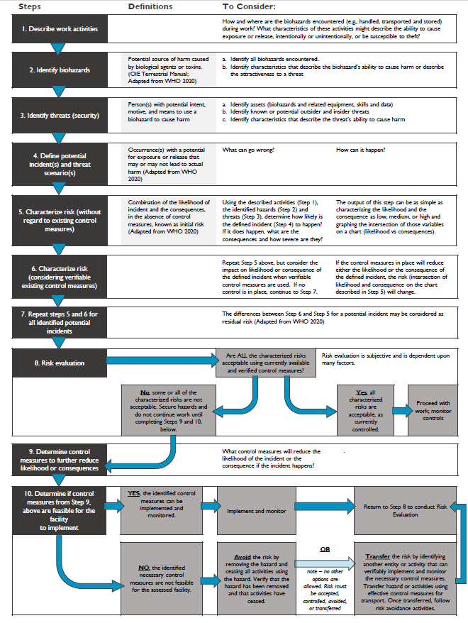

World Health Organisation (WHO), Biorisk Management: Laboratory Biosecurity Guidance, 21 June 2024, https://www.who.int/publications/i/item/9789240095113
World Health Organisation (WHO), Biorisk Management: Laboratory Biosecurity Guidance, 21 June 2024, https://www.who.int/publications/i/item/9789240095113
World Health Organisation (WHO), Biorisk Management: Laboratory Biosecurity Guidance, 21 June 2024, https://www.who.int/publications/i/item/9789240095113
Risk assessment. Geneva: World Health Organization; 200 (Laboratory biosafety manual, fourth edition and associated monographs). Licence: CC BY-NC-SA 3.0 IGO

