Insert Facility/Institute Logo Here
STANDARD OPERATING PROCEDURE (SOP) TEMPLATE
Facility:

SOP Title: Transportation and Shipping SOP

Document Number: | Version Number: 00
Process Leader: | Effective Date: MM-DD-YYYY
Other documents cross-referenced in this SOP (i.e., manuals, SOPs, forms, records):
- Biorisk Management Manual (Chapter XX, Transportation and Shipping; Chapter XV, Material Control and Accountability; and Attachments A-H)

Revision Number | Sections Changed | Description of Change | Date | Approved By

INSTRUCTIONS: The Biorisk Management Manual and supporting Standard Operating Procedure (SOP) templates provide a general overview of common considerations and information that should be addressed within a biorisk management system and program. These templates are not exhaustive and facilities must customize each document to ensure it is locally applicable and relevant.
- Black text can be considered generic text which may be appropriate for inclusion in a facility’s biorisk management manual and SOPs.
- Red text should be considered guidance or examples and must be reviewed and replaced with facility-specific information.

- Purpose
The purpose of this document is to ensure that biological agents are transported and/or shipped in public spaces (outside of the facility safely and securely with the knowledge and/or approval of appropriate personnel in the facility; and that these processes are performed in accordance with regional, national, and international regulations.

- Scope
This document applies to all facility personnel and visitors who are approved to prepare packages of biological materials for shipments or transport outside of Insert Institute/Facility Name. This SOP is written to provide guidance to prepare shipments but does not replace the need for training. Shipping regulations and Insert Institute/Facility Name require anyone who is involved in the transportation operation to be properly trained. Insert reference on who/how training for shipping is accomplished at this facility/location

- Responsibilities
- Process Leader ensures packaging materials are used and available, and that Shippers and Carriers are trained on this procedure.
- Facility personnel who are involved in the shipping or transportation of infectious materials follow the procedures outlined in this SOP and to report any problems to the Process Leader.
- Shipper makes arrangements with the recipient of specimens, assures that package is prepared in accordance with all applicable regulations and laws, obtains necessary shipping, import, and export permits where needed, packages and labels specimen safely and appropriately, completes and files appropriate facility required and other documentation as needed, arranges direct routing with considerations for cold-chain needs and security, holds appropriate certification and be trained in shipping and transportation procedures, and maintains appropriate records of all shipments made.
- Carrier completes and files appropriate facility required and other documentation as needed, arrange direct routing with considerations for cold-chain needs and security, holds appropriate certification and be trained in shipping and transportation procedures, and maintains a valid drivers’ license or other form of authorization to operate a vehicle.
- Facilities Management Office ensures that packaging, labels, and other materials necessary for safe transport of infectious materials are provided.

- Preparation
  - Materials
- Disinfectant (5.25% sodium hypochlorite solution)
- Leakproof primary container
- Leakproof secondary container
- Sufficient absorbent
- Bubble wrap or other cushioning material as needed to secure secondary containers against movement.
- Appropriate outer box for applicable shipment type: Category A, Category B or Exempt specimen; Insulated packaging for refrigerated shipment, etc.
- Appropriate hazard shipping and handling labels
  - Equipment
- Biological Safety Cabinet (BSC)
  - Records and Forms
- Shipper’s declaration (if needed)
- Waybill or other carrier required paperwork
- Itemized list of contents
- Package manufacturers use/assembly instructions

- Procedure (refer to attached flow chart for content)
  - Shipment authorization and notification
  - Packaging Operations

    - Classify biological material
Determine whether the material must be packaged and marked/labeled as a Category A infectious substance, a Category B biological substance, exempt human/animal specimen, or not regulated. Classification must be done in accordance with appropriate regulations (input reference to appropriate local regulations, e.g. IATA Dangerous Good Regulations). See attached classification flow chart for assistance.
Note: If a determination has been made the material is exempted from all shipping regulations, the following triple packaging concept should still be followed.
    - Prepare primary receptacle(s)
Depending on the nature of the biohazardous material, this is most often done inside of a BSC
        - Wear appropriate PPE and follow all specimen handling SOPs and safety precautions to seal the primary receptacle.
        - Ensure a leakproof seal is maintained on the primary (tape or parafilm can be used to secure screw cap primaries)
        - Wipe down the exterior of the primary with disinfectant (5.25% sodium hypochlorite solution)
    - Prepare secondary container
Depending on the nature of the biohazardous material, this step occasionally must be performed inside a BSC
        - Read and follow package manufacturer’s directions to prepare the secondary.
        - Multiple primaries placed inside a single secondary must be wrapped individually or separated to prevent contact between them. Ensure that the quantity limits for the number, type and volume of primaries as indicated in the manufacturer’s directions are followed.
        - Place enough absorbent to absorb all contents of the primaries should they leak.
        - Ensure that primaries are secured within the secondary to prevent movement or shifting during the transport operation. This can be accomplished by using absorbent material, bubble wrap, padding, or other filler.
        - Do not place dry ice inside the secondary container.
        - Seal the secondary according to manufacturer’s directions. Confirm that there is a leakproof seal.

    - Prepare outer packaging
        - Follow the manufacturer’s directions to properly place the secondary(ies) within the outer packaging.
        - Add refrigerant if required (dry ice or gel packs, avoid the use of wet ice).
        - Place an itemized list of contents between the secondary(ies) and the outer package. This could be a requisition form or a typed letter describing the number and types of primaries and a basic description of their contents.
        - Use dividers, newspaper, paper towels, bubble wrap or other filler to secure the secondary(ies) inside the outer package to insulate against movement, shaking and breakage.

    - Mark and label outer packaging
Depending on the nature of the shipment, marks and labels may include the following (see package marking and labeling diagrams and checklist in the appendix):
        - To and From addresses
        - Contact information for the shipper and consignee
        - Name and telephone number of a person responsible for the shipment
        - Appropriate hazard label(s)
        - Proper shipping name(s)
        - Quantity of the dry ice (if applicable)

    - Complete paperwork
Depending on the nature of the shipment, the following paperwork may need to be completed:
        - For Category A shipments, three copies of the shipper’s declaration for dangerous goods are required (see sample shipper’s declaration and checklist in the appendix). One copy must be retained by the shipper and two copies given to the carrier.
        - Waybill (provided by the carrier), usually includes To/From addresses and contact information and a description of the material and packaging.

    - Make arrangements for transport
        - Keep package secure prior to pick up. Follow appropriate security procedures (insert any facility specific security requirements here). Do not leave unattended in locations accessible to unauthorized personnel.
        - Under no circumstances will public transportation services be used to transport infectious substances between facilities.
  - Transportation operations carried out by Insert Institute/Facility Name.

NOTE: Sometimes, infectious substances are shipped with dry ice. Dry ice is classified by UN 1845 as a Class 9 miscellaneous hazard. There are three important safety factors to consider when using dry ice:
1. DO NOT PLACE DRY ICE IN PRIMARY OR SECONDARY CONTAINERS as these containers must be tightly sealed which can lead to explosions.
2. Only use dry ice in a well-ventilated area.
3. Dry ice is extremely cold, always handle with care and wear protective gloves and eyewear. Use mechanical device (e.g., tongs) to handle.

- References
- World Health Organisation (WHO) Guidance on Regulations for the Transport of Infectious Substances 2021-2022: https://apps.who.int/iris/handle/10665/339825
- (IATA) Dangerous Goods Regulations: http://www.iata.org/publications/dgr/Pages/index.aspx
- United Nations Recommendations on the Transport of Dangerous Goods: http://live.unece.org/trans/danger/publi/unrec/12_e.html
- International Civil Aviation Organization (ICAO) Technical Instructions for the Safe Transport of Dangerous Goods by Air: https://www.icao.int/safety/dangerousgoods/pages/technical-instructions.aspx
(Additional local or national laws, guidelines or regulations related to shipping and transportation of infectious substances should be documented here)
- Attachments
- Transportation and Shipping Flow Chart
- World Health Organisation (WHO) Guidance on Regulations for the Transport of Infectious Substances 2021-2022: https://apps.who.int/iris/handle/10665/339825
- IATA Guidance Document on Infectious Substance Shipping: https://www.iata.org/en/publications/store/infectious-substances-shipping-guidelines/
- IATA Packing Instruction 620, Toxic and Infectious Substances
- IATA Packing Instruction 650, General Requirements:
https://www.iata.org/contentassets/b08040a138dc4442a4f066e6fb99fe2a/dgr-62-en-pi650.pdf
- Classification Summary Sheet
- IATA Dangerous Goods Table
- Category A & B Comparison Chart
- Packaging Checklist, Marking and Labeling Checklist, Shipper’s Declaration Checklist
- Transportation and Shipping SOP Flow Chart

(Additional attachments developed by the facility should be documented here)

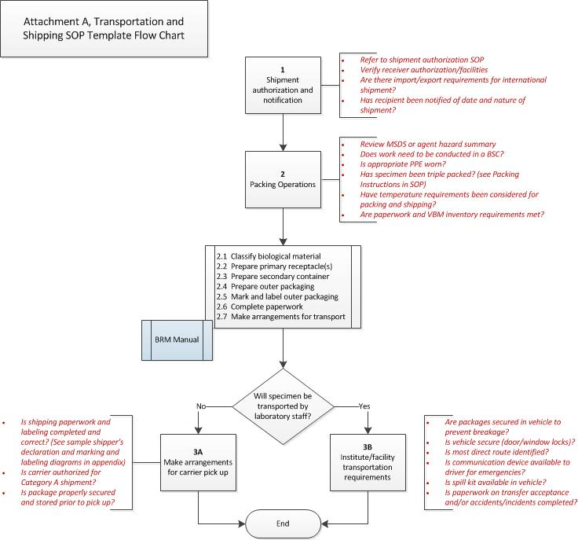
- Is shipping paperwork and labeling completed and correct?
- Is carrier authorized for Category A shipments?
- Is package properly secured and stored prior to pick up?
- Are packages secured in vehicle to prevent breakage?
- Is vehicle secure (door/window locks)?
- Is most direct route identified?
- Is a communication device available to the driver for emergencies?
- Is a spill kit available in the vehicle?
- Is paperwork on transfer acceptance and/or accidents/incidents completed?
Will specimen be transported by facility staff?
- Review SDS or agent hazard summary
- Does work need to be conducted in a BSC?
- Is appropriate PPE worn?
- Has specimen been triple packed?
- Have temperature requirements been considered for packaging and shipping?
- Are paperwork and VBM/ MC&A inventory requirements met?
- Refer to shipment authorization SOP
- Verify receiver authorization/facilities
- Are there import/export requirements for international shipment?
- Has the recipient been notified of date and nature of shipment?

