Insert Facility/Institute Logo Here
SHIPPING AND TRANSPORTATION PROGRAM PLAN TEMPLATE
Facility:

Manual Title: Shipping and Transportation Program Plan

Document Number: | Version Number: 00
Process Leader: | Effective Date: MM-DD-YYYY
Other documents cross-referenced in this manual (e.g., manuals, SOPs, forms, records):
- Shipping SOP (X-0X-00X)
- Valuable Biological Materials SOP (1-04-002)
- Incident Response Plan (9-00-001)

Revision Number | Sections Changed | Description of Change | Date | Approved By
INSTRUCTIONS: The Shipping and Transportation Manual and supporting Standard Operating Procedure (SOP) templates provide a general overview of common considerations and information that should be addressed when shipping and transporting possibly infectious biological substances domestically or internationally, no matter the mode of transportation. These templates are not exhaustive; facilities must customize each document to ensure it is locally applicable and relevant.
- Black text can be considered generic text that may be appropriate for inclusion in a facility’s operations manual and SOPs.
- Red text should be considered guidance or examples and must be reviewed and replaced with facility-specific information.

Table of Contents
Policies and General Management
- Purpose
- Principle
- Roles and Responsibilities
- Definitions and Abbreviations
Classification of Dangerous Goods
- Background
- Classifications
- Other Classifications
Packing
- Background
- Packing Category A Substances
- Packing Category B Substances
- Packing Exempt Substances
- Packing with Dry Ice
- Budgeting and Procurement of Supplies
Marking and Labeling
- Background
- Marking and Labeling Packages Containing Category A Substances
- Marking and Labeling Packages Containing Category B Substances
- Marking and Labeling Packages Containing Miscellaneous Dangerous Goods
Documentation
- General Information
- Documents Required for Handling Category A Substances
- Documentation Required for Inventory Management
- Chain of Custody
Training
- General Information
- Institutional Training Requirements
- Institutional Shipping Roles
Organizational Operation
- Shipment Authorization and Notification
- Access Control of Storage/Transport/Shipping Areas
- Material Control and Accountability
Transportation
- Reliability of Carriers
- Vehicle Use
- Two-Person Rule
- Transport within facility
- Incident Response
References and Attachments

Policies and General Management
- Purpose
The purpose of this document is to provide [Insert Facility Name] with the means to properly package, mark, label, and prepare biological materials, no matter the type of material, destination, or mode of transport, for transport. This manual contains institutional policies, general information about facility operations and references to applicable international and national regulations and guidelines that protect the safety and security of facility personnel, visitors, the general public, and the surrounding environment from the mishandling or damage to containers carrying infectious substances intended to be shipped and/or transported. This manual is supported by a set of SOPs and attachments that describe relevant procedures to properly ship, mark, label, prepare, and transport infectious substances.

- Principle
The scope of [Insert Facility Name]’s shipping and transportation manual is to ensure the knowledge of employees directly involved with the classification, packaging, marking, labelling, and ultimate shipping of biological goods. Similar to how effective biosafety practices protect the facility workers, environment, and public from accidental exposure to an infectious agent at a given facility, the following practices and regulations protect from exposure during shipping and transportation of infectious agents. While specific regulations may vary from country to country, adherence to the International Air Transport Association’s (IATA) Dangerous Goods Regulations is a method recognized around the world to provide a facility with the means to not only comply with their country’s regulations and the regulations set about by the International Civil Aviation Organization (ICAO—an agency created by the United Nations), but also ensure that the best effort is taken to protect involved parties against exposure. IATA regulations are updated annually, and [Insert Facility Name] will ensure the program plan is updated with relevant changes in the regulations. The [Insert Facility Name] will further ensure that all shipping and transportation operations are in accordance with the facility’s risk assessments.

- Roles and Responsibilities
- Top and Senior Management will aid an organization to develop and enforce a biosafety program: a set of tools, information and associated actions that are overseen, enforced and continuously improved upon, by an organization’s senior management.
- Process Leader ensures packaging materials are used and available, and that Shippers and Carriers are trained on this procedure.
- Biorisk Management Advisor (or Biosafety Officer) advises upon this and other processes covered under facility or organizational biosafety and biosecurity programs.
- Facility personnel who are involved in the shipping or transportation of infectious materials are responsible for adhering to the procedures outlined in this SOP and to report any problems to the Process Leader.
- Shipper makes arrangements with the recipient of specimens, assures that package is prepared in accordance with all applicable regulations and laws, obtains necessary shipping, import, and export permits where needed, packages and labels specimen safely and appropriately, completes and files appropriate facility required and other documentation as needed, arranges direct routing with considerations for cold-chain needs and security, holds appropriate certification and is trained in shipping and transportation procedures, and maintains appropriate records of all shipments made.
- Carrier completes and files appropriate facility required and other documentation as needed, arrange direct routing with considerations for cold-chain needs and security, holds appropriate certification and is trained in shipping and transportation procedures, and maintains a valid drivers’ license or other form of authorization to operate a vehicle.
- Facilities Management Office is responsible for equipment and facilities, typically engineers with in-depth knowledge of biological work facilities, containment equipment and buildings, coordinating building and maintenance work, and liaising with contractors.
- Definitions and Abbreviations

Classification: Groups of dangerous goods as defined by IATA. There are 9 Classes which may be further divided into Divisions, ex. Class 9.2.
Dangerous Goods: Articles or substances which are capable of posing a risk to health, safety, property or the environment. Those goods which meet the criteria of one or more of the nine UN hazard classes
IATA: International Air Transport Association
IATA Dangerous Goods Regulations: International regulatory standard for air shipments that incorporates all ICAO/UN requirements and most national regulations for shipping dangerous goods.
Labeling: Hazard labels required for most dangerous goods are diamond shaped. Handling labels required for some dangerous goods have various shapes. Labels are affixed to outside of each package.
Marking: Writing that indicates the contents of package, nature of hazard, uses applicable packaging standards, and must be clearly visible.
Packaging: Specific process based on risk assessment and regulations to enclose biological materials to reduce risk of mishandling, leaking, breakage, exposure, diversion, or theft during transport.
Shipping: Utilization of third-party carriers to transport biological materials within a country or across international borders.
Transport: The movement of biological material outside of a restricted area or in the field (e.g. research teams may transfer samples for study, and public health labs may transfer samples for diagnosis and analysis). Transport can occur across international borders, within a country, or within a facility.
UN Specification Mark: A mark that indicates a package has been approved in accordance with the testing requirements of the UN Model Regulations.

Classification of Dangerous Goods
- Background
The shipping facility must first classify dangerous goods to be shipped to define how they will be packaged and labeled. The greater potential of a substance to infect someone, the bigger risk it is, and more care is needed to ensure safe transport. IATA has defined nine classes of dangerous goods, in which infectious substances occupy Class 6, division 2 (other classes include explosives, gases, and radioactive materials). Adherence to IATA regulations is required when shipping materials across international borders but can be followed as an industry best practice for shipping and transportation within a country. The collection of infectious substances used by this facility can be further divided into the following groups: [remove substances not present or applicable to facility]
NOTE: It is the responsibility of the designated Biorisk Management Advisor or similar biological professional at this facility to use best judgment when assigning biological substances to the appropriate groups. If there is a reasonable doubt as to how a substance should be classified, it is the safest practice do ship it as if it were a Category A substance.
- Classifications

Category A Substances
A substance that is deemed Category A by IATA regulations is “transported in a form that, when exposure to it occurs, is capable of causing permanent disability, or life threatening or fatal disease in otherwise healthy humans or animals.” These substances must be labeled with the appropriate UN numbers and shipping designations, either UN 2814, “Infectious substance, affecting humans,” or UN 2900, “Infectious substance, affecting animals.” Examples of substances are provided in Attachments B, C, and D.

Category B Substances
Substances that are deemed Category B by IATA regulations “do not meet the criteria for inclusion in Category A.” That is, while these substances are infectious, they do not threaten the life of any otherwise healthy human or animal who becomes exposed. These substances must be labeled with the appropriate UN number and shipping designation, UN 3733, “Biological substance, Category B.” Examples of substances are provided in Attachments B, C, and D.

Exempt Substances and Specimens
Substances to be shipped that are not suspected to be infectious as categorized under Category A or B, that is, substances that are unlikely to cause disease in humans or animals, or substances not being tested for the presence of Category A or B pathogens are exempt from complying with dangerous goods regulations.
Exempt substances include but are not limited to:
- materials known to be free of infectious substances;
- inactivated biological agents;
- non-pathogenic biological agents;
- dried blood spot or fecal occult blood specimens transported for analysis;
- environmental specimens not considered to be a significant hazard to health;
- items for transplant or transfusion;
- biological products, such as vaccines and drugs, that are distributed for beneficial purposes.
If, after examination, it is unclear whether a substance should be exempt from dangerous goods regulation, ship as a Category B infectious substance.

Human or animal specimens that are exempt must be shipped in the appropriate triple packaging (see Packaging section) and be clearly marked “Exempt Human Specimen” or “Exempt Animal Specimen.” Examples of substances are provided in Attachments B, C, and D.

Medical or Clinical Waste
Waste containing Category A substances must be designated as UN 3549 (Category A solid medical waste), while waste containing Category B substances must be designated UN 3291 (“Biomedical waste, n.o.s.,” “Clinical waste, unspecified, n.o.s.,” “Medical Waste, n.o.s.,” or “Regulated medical waste, n.o.s.”). Waste shipments not containing Category A or B substances are exempt from the IATA Dangerous Goods Regulations.

Dry Ice
Dry ice is considered a Class 9 dangerous good and is often included for shipping of biological materials that must be kept frozen.

- Other Classifications as Determined by Local or Institutional Policies and Regulations
Since the regulations posed in this manual only strictly apply to international shipping of dangerous goods, it is important to also adhere to local regulations when shipping in-country. This could mean that dangerous goods have unique classifications in specific countries, and [Insert Facility’s Name] must be aware of these regulations and adapt this manual appropriately.

Packing
- Background
Biological substances - whether infectious or not - are triple packaged. Category A or B substances are shipped using approved triple packaging systems, regardless of the mode of transportation. This system is also recommended for transport between buildings or workspaces within the facility. While these regulations may or may not be required for shipping domestically, depending on local laws, it is highly recommended that [Insert Facility’s Name] follows a similar technique to packaging their dangerous goods to ensure the safety of those involved with its transportation.

The triple packing system is composed of the following layers (see Figure 1):
- Primary packaging: The primary container holds the sample itself, for example, a test tube. It must be leak-proof and tightly sealed to prevent the infectious substance from escaping. The use of a positive means to ensure a leakproof seal is recommended, such as a crimp seal on a Prubber stopper or tape on a screw cap.
- Secondary packaging: A second leak-proof and tightly sealed container encloses the primary packaging that prevents the escaping of biological material in the event that the primary receptacle is damaged. This could be a sealed bag or hard-sided glass or plastic container. Absorbent material, sufficient to absorb the entire contents of the primary container(s) is sealed inside the secondary packaging. Absorbent padding or other means are employed to secure the primary container(s) to prevent breakage. An itemized list of contents, describing the number and type of primary containers and information on their contents is enclosed between the secondary and outer packaging.

NEVER ADD DRY ICE TO THE SECONDARY CONTAINER!

- External packaging: A strong and rigid container encloses the secondary packaging, while providing sufficient cushioning to restrict the movement of and protect the secondary packaging if external forces are exerted upon the external packaging. This could be a box with packing material, a cooler, a courier container, or other enclosure for transport.

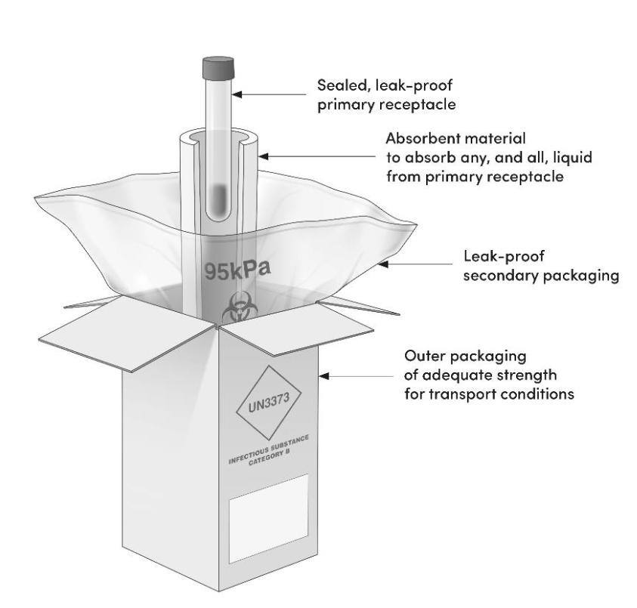
Figure 1: Example of Triple Packaging of Category B infectious substances. (WHO, 2021)
Additional examples of materials used in packaging are provided in Attachments A and E.

- Packing Category A Substances
Category A infectious substances are transported according to the United Nations Packing Instruction P620 when shipped across international borders. The packaging must meet UN packaging test standards as described in the IATA Dangerous Goods Regulations. The outer packaging will be marked with UN specification mark.

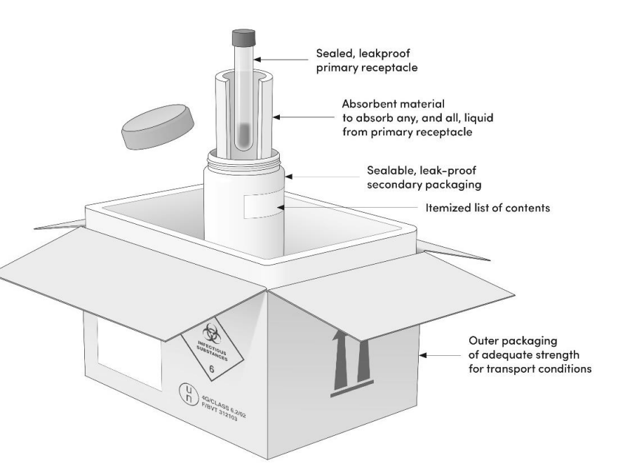
Figure 2. Example of Triple Packaging of Category A infectious substances. (WHO, 2021)
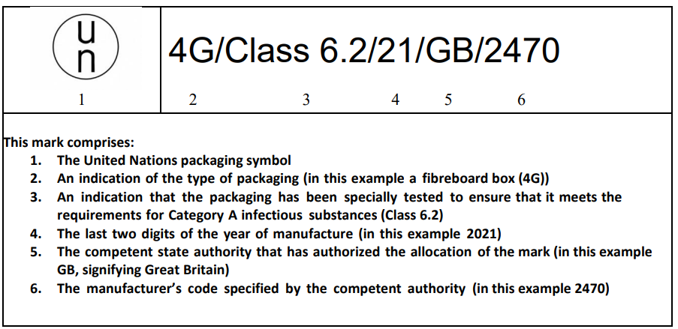
Figure 3. Example of UN specification mark for Category A packaging. (WHO, 2021)
- Packing Category B Substances
Category B infectious substances are transported according to the United Nations Packing Instruction P650.

- Exempt Specimens
Exempt specimens, while exempt from UN specification marking, labeling, and documentation regulations, are triple packaged to prevent damage or leakage during shipping.

- Packing with Dry Ice
Dry ice and other refrigerants are commonly used to help keep substances cold during shipping. Dry ice is an explosive hazard when it is not allowed to depressurize during sublimation, and therefore is placed outside any sealed secondary packaging. If dry ice was placed in either the primary or secondary packaging, the package could become greatly damaged and leak its contents into the surrounding areas. It is required, therefore, that dry ice be placed within the external packaging in a manner that permits the release of gaseous carbon dioxide. A large amount of dry ice is also an asphyxiation hazard when shipped in the pressurized cabin of an airplane. Therefore, when shipped by air, dry ice is considered a Class 9 dangerous good. Air cargo handlers must be aware of the amount of dry ice loaded on an airplane.

- Budgeting and Procurement of Supplies
Facilities Management Office must ensure adequate quantities of supplies for packaging, labelling, and transport are available for the safe movement of materials within the facility and outside of the facility. As many of these items are consumable and single use, the facility’s budget needs to include ongoing funding the procure and reorder these vital materials. If the facility chooses to invest in reusable materials that are glass, durable plastic or metal, appropriate disinfection methods need to be identified to ensure the integrity of the container(s) is not compromised.

Marking and Labeling
- Background
Marking and labeling of dangerous goods is a vital part of the shipping process as it informs the carrier of the package’s contents, giving insight to how carefully it should be handled. It is important that all markings can be identified on the exterior of the package to show compliance with dangerous goods regulations. Markings required for the different categories of substances are shown below. These markings and labels are not required for in-country shipping or movement within the facility, but similar techniques are highly recommended so that all involved with shipping are aware that dangerous substances are being handled. A label with the biohazard symbol clearly visible is the minimum labeling required for containers transported within the institution (via hand-carried coolers and containers or push carts). The labeled container is used only for transport of infectious materials.
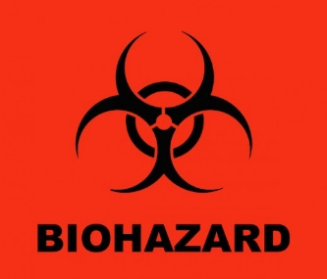
Figure 4. Biohazard symbol.
- Marking and Labeling for Category A Substances
The exterior of packages containing Category A substances must be marked with the following:
  - UN designations, either UN 2814 “Infectious substance, affecting humans,” or UN 2900 “Infectious substance, affecting animals.” diamond-on-point label
    - These diamond-shaped hazard labels are easily recognizable, unique to the category of substance being shipped, and are required to be displayed to comply with dangerous goods regulations.
A.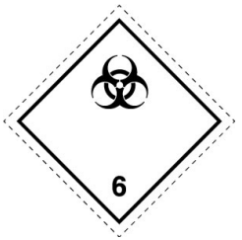B.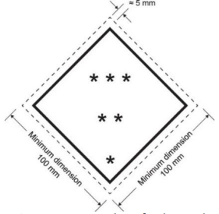
Figure 5. Category A Infectious substance label (A) and template showing required sizes (B) (WHO, 2021)

- the name and address of the shipper
- the name and address of the receiver
- the name and telephone number of a person responsible for the package
    - This could be the shipper, the receiver or the safety officer for the facility.
    - This person should be knowledgeable about the contents of the package and able to provide clean up and exposure mitigation information if the package were damaged or lost in transit.
- additional required labels, e.g., biohazard, dry ice, directional arrows, etc.

A.B. 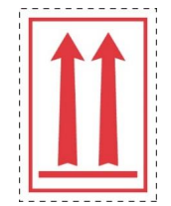
Figure 6. Examples of other potential labels required (WHO, 2021). A.
Miscellaneous dangerous good label would be used for dry ice containing shipments (Class 9). B. Orientation labels, required when liquid shipments of category A material exceeds 50 ml.

For security reasons, the pathogen name should not appear on the external packaging and may be included in the itemized list of contents and sealed within the package.

- Marking and Labeling for Category B Substances
The exterior of packages containing Category B substances must be marked with the following:
  - designation UN3373 diamond-on-point with the text “Biological substance, Category B”
  - name and address of the shipper,
  - name and address of the receiver.
  - name and phone number of a person responsible
  - additional required labels, e.g., biohazard, dry ice, etc.
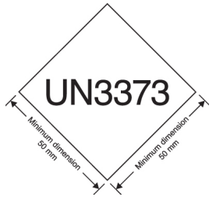
Figure 7. Category B label. (WHO, 2021).

For security reasons, the pathogen name should not appear on the external packaging and may be included in the itemized list of contents and sealed within the package.

- Marking and Labeling Packages That Contain Miscellaneous Dangerous Goods
Because of the potential for dry ice to sublimate and displace the oxygen in a pressurized aircraft, dry ice is only classified as a dangerous good for shipment by air. Possible miscellaneous dangerous goods being shipped, for example dry ice or other compounds used to cool the primary substances, also require UN markings specific to the type of compound be displayed, as well as the appropriate hazard labels. When shipping dry ice by air, in addition to the Class 9 label, you must include the “Dry Ice” “UN1845” diamond-on-point label and mark the weight of the dry ice.

Documentation
- General Information
Documentation is required when shipping any package containing dangerous goods, e.g., invoices, permits. Specific documents are required by the IATA Dangerous Goods Regulations when shipping packages containing Category A substances.

- Documents Required for Handling Category A Substances
When a Category A infectious substance is shipped internationally by air, the facility is required to submit a Declaration for Dangerous Goods. This document details the place of origin, the destination, as well as the contents of the package. When dry ice is included in the package, the dry ice is also recognized as a dangerous good on the Declaration form but only for Category A shipments.

- Documentation for Material Control and Accountability
It is important for [Insert Facility’s Name] to maintain accurate documentation for material control and accountability management. This includes, for example, recognizing when an infectious substance has been added or removed from the facility’s inventory. Monitoring valuable biological materials is vital to understanding the movement of infectious substances into, out of, and within the facility, and tracking who is accountable for each infectious substance. When biological materials are transported or moved within the facility, inventory locations must be updated. Refer to the facility’s Valuable Biological Materials Document (Document #) for information on this process.

- Chain of Custody
To ensure that the shipping of infectious substances is performed according to established procedures by facility personnel, the chain of custody for the material(s) being shipped is documented. The exact path taken by the substance will be at the discretion of the facility, but the ideas to be presented in this manual must be adapted to any scenario.

Transfer to another laboratory within the institution.
  - Laboratory manager or director authorizes transfer of the material on the Chain of Custody document.
  - The material classification is assigned by the [insert position providing classification].
  - Personnel trained to ship infectious substances:
    - contact the receiving laboratory to confirm pending transfer and documents name, date, and time of contact on the form.
    - remove material from inventory and document removal in the inventory log.
    - triple-package material(s) for transport (including packing list) and labels outer container according to IATA Category regulations.
    - transports properly packaged material(s) to the receiver who signs the Chain of Custody document.
  - A copy of the completed Chain of Custody document is made for the receiver’s records.
  - Receiving laboratory personnel enters the material into the laboratory’s inventory.
  - Shipper and receiver retain all documentation.

Transfer to different institution.
  - Laboratory manager or director authorizes transfer of the material on the Chain of Custody document.
  - The material classification is assigned by the [insert position providing classification].
  - Personnel trained to ship infectious substances:
    - contact the receiving laboratory to confirm pending shipment and documents name, date, and time of contact on the form.
    - remove material from inventory and document removal in the inventory log.
    - triple-package material(s) for transport (including packing list and permit if required) and labels outer container according to IATA Category regulations.
    - complete Dangerous Goods Declaration form (if Category A shipment) and retains a copy of the completed form.
    - transports properly packaged material(s) to the shipper (3rd party, courier, etc.) who signs the Chain of Custody document.
    - Notifies receiver of expected delivery date.
  - Receiver notifies shipper of receipt of package or if package is not received on the date expected. (see Incident Management section)
  - A copy of the completed Chain of Custody document is made for the receiver’s records.
  - Receiving laboratory personnel enters the material into the laboratory’s inventory.
  - Shipper and receiver retain all documentation.

Training
- General Information
[Insert Facility’s Name] personnel involved with the shipping and transportation of the dangerous goods described in this manual, must be trained as required by the ICAO/IATA. Training supplies the user with the proper and certifiable knowledge on the regulatory required aspects of shipping and transportation. The WHO publishes guidelines based on the ICAO/IATA regulations, which state, only those that handle Category A substances must receive formal training, while those handling Category B substances and Exempt Specimens need only learn about the use of the packaging, as well as packing substances appropriately. According to IATA, however, all employees involved with shipping and transportation of Category A and B substances, as well as Exempt Specimens, must receive formal training. IATA-certified instructors are available who provide training and certify participants. Certification, however, is not valid forever as regulatory requirements direct that training be renewed every 2 or so years (depending on the agency). While some employees at certain facilities may not be required to be IATA certified (for example, if the substances the facility ships are only being shipped in-country), it is still recommended that employees are trained on the topics discussed in this manual.
- Institutional requirements for competency-based assessment and documentation of employee proficiency
  - IATA based dangerous goods training guidance emphasizes competency-based training that incorporates a routine assessment process for the competency/proficiency to perform a given job function.
  - Identify the appropriate job functions based on their shipping programs and needs.
  - Document training for each job function and include:
    - shipping training requirements,
    - competency measurement,
    - proficiency evaluation, and
    - assessment.
  - Have specific training and assessment plans for shipping training in order to comply with IATA Dangerous Goods Shipping Guidance: Competency-based training and assessment approach.

- Institutional Roles
The following roles require training:
- [Insert Facility’s Name] Shipping staff
Those involved with preparing infectious substances to be shipped must be properly trained on the methods described in this manual. Failure to adhere to these methods could put everyone at risk of exposure. It is up to the discretion of the management at [Insert Facility’s Name] to create a work environment in which the following questions can be answered about employee conduct:
  - Are employees aware of the consequences of mishandling substances during packaging?
  - Do employees know how to properly adhere to the described methods of classification, packaging, marking, and labeling?
  - Do employees treat packages with care?
  - Do employees understand the importance of inventory control?
  - [Insert any additional topics that are important to the facility and their employees here]
- [Insert Facility’s Name] Carriers/couriers/drivers
It is important that those who are physically transporting the infectious substances are reliable employees who understand the biosecurity risks of moving these substances from one facility to another. These employees must be properly trained. It is up to the discretion of the management at [Insert Facility’s Name] to create a work environment in which the following questions can be answered about employee conduct:
  - Is the carrier/courier hired through a third party or is he/she an employee of the facility?
  - Has the carrier/courier been vetted to handle potentially dangerous substances and can be relied upon to not make any unscheduled stops?
  - Does the carrier/courier understand the biosecurity risk of transporting these substances?
  - Does the carrier/courier leave the package unattended at any time during transportation?
  - Does the carrier/courier understand what to do in the event the package becomes damaged (and its contents become exposed to the environment) during transportation?

Organizational Operation
- Shipment Authorization and Notification
In order for infectious substances to be shipped to their desired destination, the shipment must first be approved by the facility’s designated authorization employee. All authorizations to ship infectious substances must documented. Failure to authorize a shipment could lead to discrepancies in material control and accountability. The facility must also notify the designated recipient of the shipping date and package(s) to be shipped. Authorization of shipment of a specific substance initiates the process of classification, packaging, marking, and labelling.

- Access Control of Storage/Transport/Shipping Areas
To ensure the security of substances being shipped, it is important to limit access to areas of the facilities designated for storage and preparation of these substances. A biosecurity risk assessment must be performed to ensure that infectious substances cannot be easily obtained for intentional release. Consult the Biorisk Management Manual for more information regarding biosecurity and risk assessments.

- Material Control and Accountability
The transport and shipment of biological materials entering, transferred within or shipped outside of the facility are considered part of [Insert Facility’s Name] biorisk management program.

All valuable biological materials must be assigned to a laboratory manager or supervisor who is knowledgeable about the material. The accountable staff member is responsible for the tracking, disposition, security, and documentation of any transfers or shipment of material for which they are accountable. Consult the Valuable Biological Materials SOP (Document #1-04-002) for additional information.

Transportation
- Reliability of Carriers
Since carriers/couriers are personally responsible for the safe transportation of infectious substances, it is vital that carrier/couriers are aware of the importance of the situation and be held accountable for their actions. Please refer to the section of this program plan titled “Institutional Training Requirements” for specific information about how carrier/couriers should be vetted and properly trained to transport infectious substances within the facility or externally.

- Transport Vehicles
The type of vehicle used to transport dangerous goods effects biosecurity measures the facility must take, such as:
- Vehicles with Doors (i.e. vans, sedans, etc.)
  - Are doors locked when the vehicle is unattended?
  - Are windows rolled up and secure when the vehicle is unattended?
  - Is the package tightly secured when inside the vehicle (in other words, does the package slide around the car when in motion?)?
  - Is the vehicle operated and maintained appropriately?
- Motor Bikes and Similar Vehicles
  - Is the package securely attached to the bike?
  - Is the bike able to be locked to an object if left unattended?
  - Is the package able to be locked if it is left unattended?
- Is a communication device available to carrier/courier for emergencies?
- Is the most direct route identified?
- Is a spill kit available in vehicle?
- Is paperwork on transfer acceptance and/or accidents/incidents completed?

- Two-Person Rule
The “two-person rule” for the transportation of all dangerous biological materials is used, both within the institution and between institutions when using facility carriers/couriers. Having two knowledgeable personnel transporting the valuable biological material(s) ensures that appropriate safety and security measures can be taken if one of the carriers/couriers is injured, the package is compromised, or other incidents arise.

- Transport within facility
To mitigate the risk of unintentional exposures from dropping or spilling, infectious or valuable biological materials during routine transport within the facility, these materials must be transported in sealed leakproof and shatterproof containers. Based on a risk assessment of the materials being transported (number of containers, volume of material, etc.) and the selected route (public areas, outdoors, etc.), a wheeled cart may be required to reduce risk of unintentional release. Use of the two-person rule is based on the risk assessment. Documentation must be completed for any destruction, propagation, or change in material location in the material control and accountability system as required in the Valuable Biological Materials SOP (Document #1-04-002).

- Incident Response
Refer to the Shipping Incident Response Plan (Document #) for the appropriate response to incidents during shipping or transportation.
- Is spill kit available in proximity to route?
- Is paperwork on inventory control and/or accidents/incidents completed?

References and Attachments
References
- World Health Organisation (WHO) Guidance on Regulations for the Transport of Infectious Substances 2021-2022: https://apps.who.int/iris/handle/10665/339825
- (IATA) Dangerous Goods Regulations: http://www.iata.org/publications/dgr/Pages/index.aspx
- United Nations Recommendations on the Transport of Dangerous Goods: http://live.unece.org/trans/danger/publi/unrec/12_e.html
- International Civil Aviation Organization (ICAO) Technical Instructions for the Safe Transport of Dangerous Goods by Air: https://www.icao.int/safety/dangerousgoods/pages/technical-instructions.aspx
- ISO 35001:2019, Biorisk management for laboratories and other related organisations. https://www.iso.org/standard/71293.html
- (IATA) Dangerous goods shipping guidance : Competency-based training and assessment approach. Ed. 1 2022.
- (Additional local or national laws, guidelines or regulations related to shipping and transportation of infectious substances should be documented here)

Attachments
- WHO Guidance on Regulations for the Transport of Infectious Substances 2021-2022: https://apps.who.int/iris/bitstream/handle/10665/339825/9789240019720-eng.pdf?sequence=1&isAllowed=y
- Classification Summary Sheet
- IATA Dangerous Goods Table
- Category A & B Comparison Chart
- Packaging Checklist, Marking and Labeling Checklist, Shipper’s Declaration Checklist
- Transportation and Shipping Flow Chart
- Shipping Incident Response Plan
H Chain of Custody form
(Additional attachments developed by the facility should be documented here)

