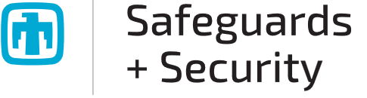

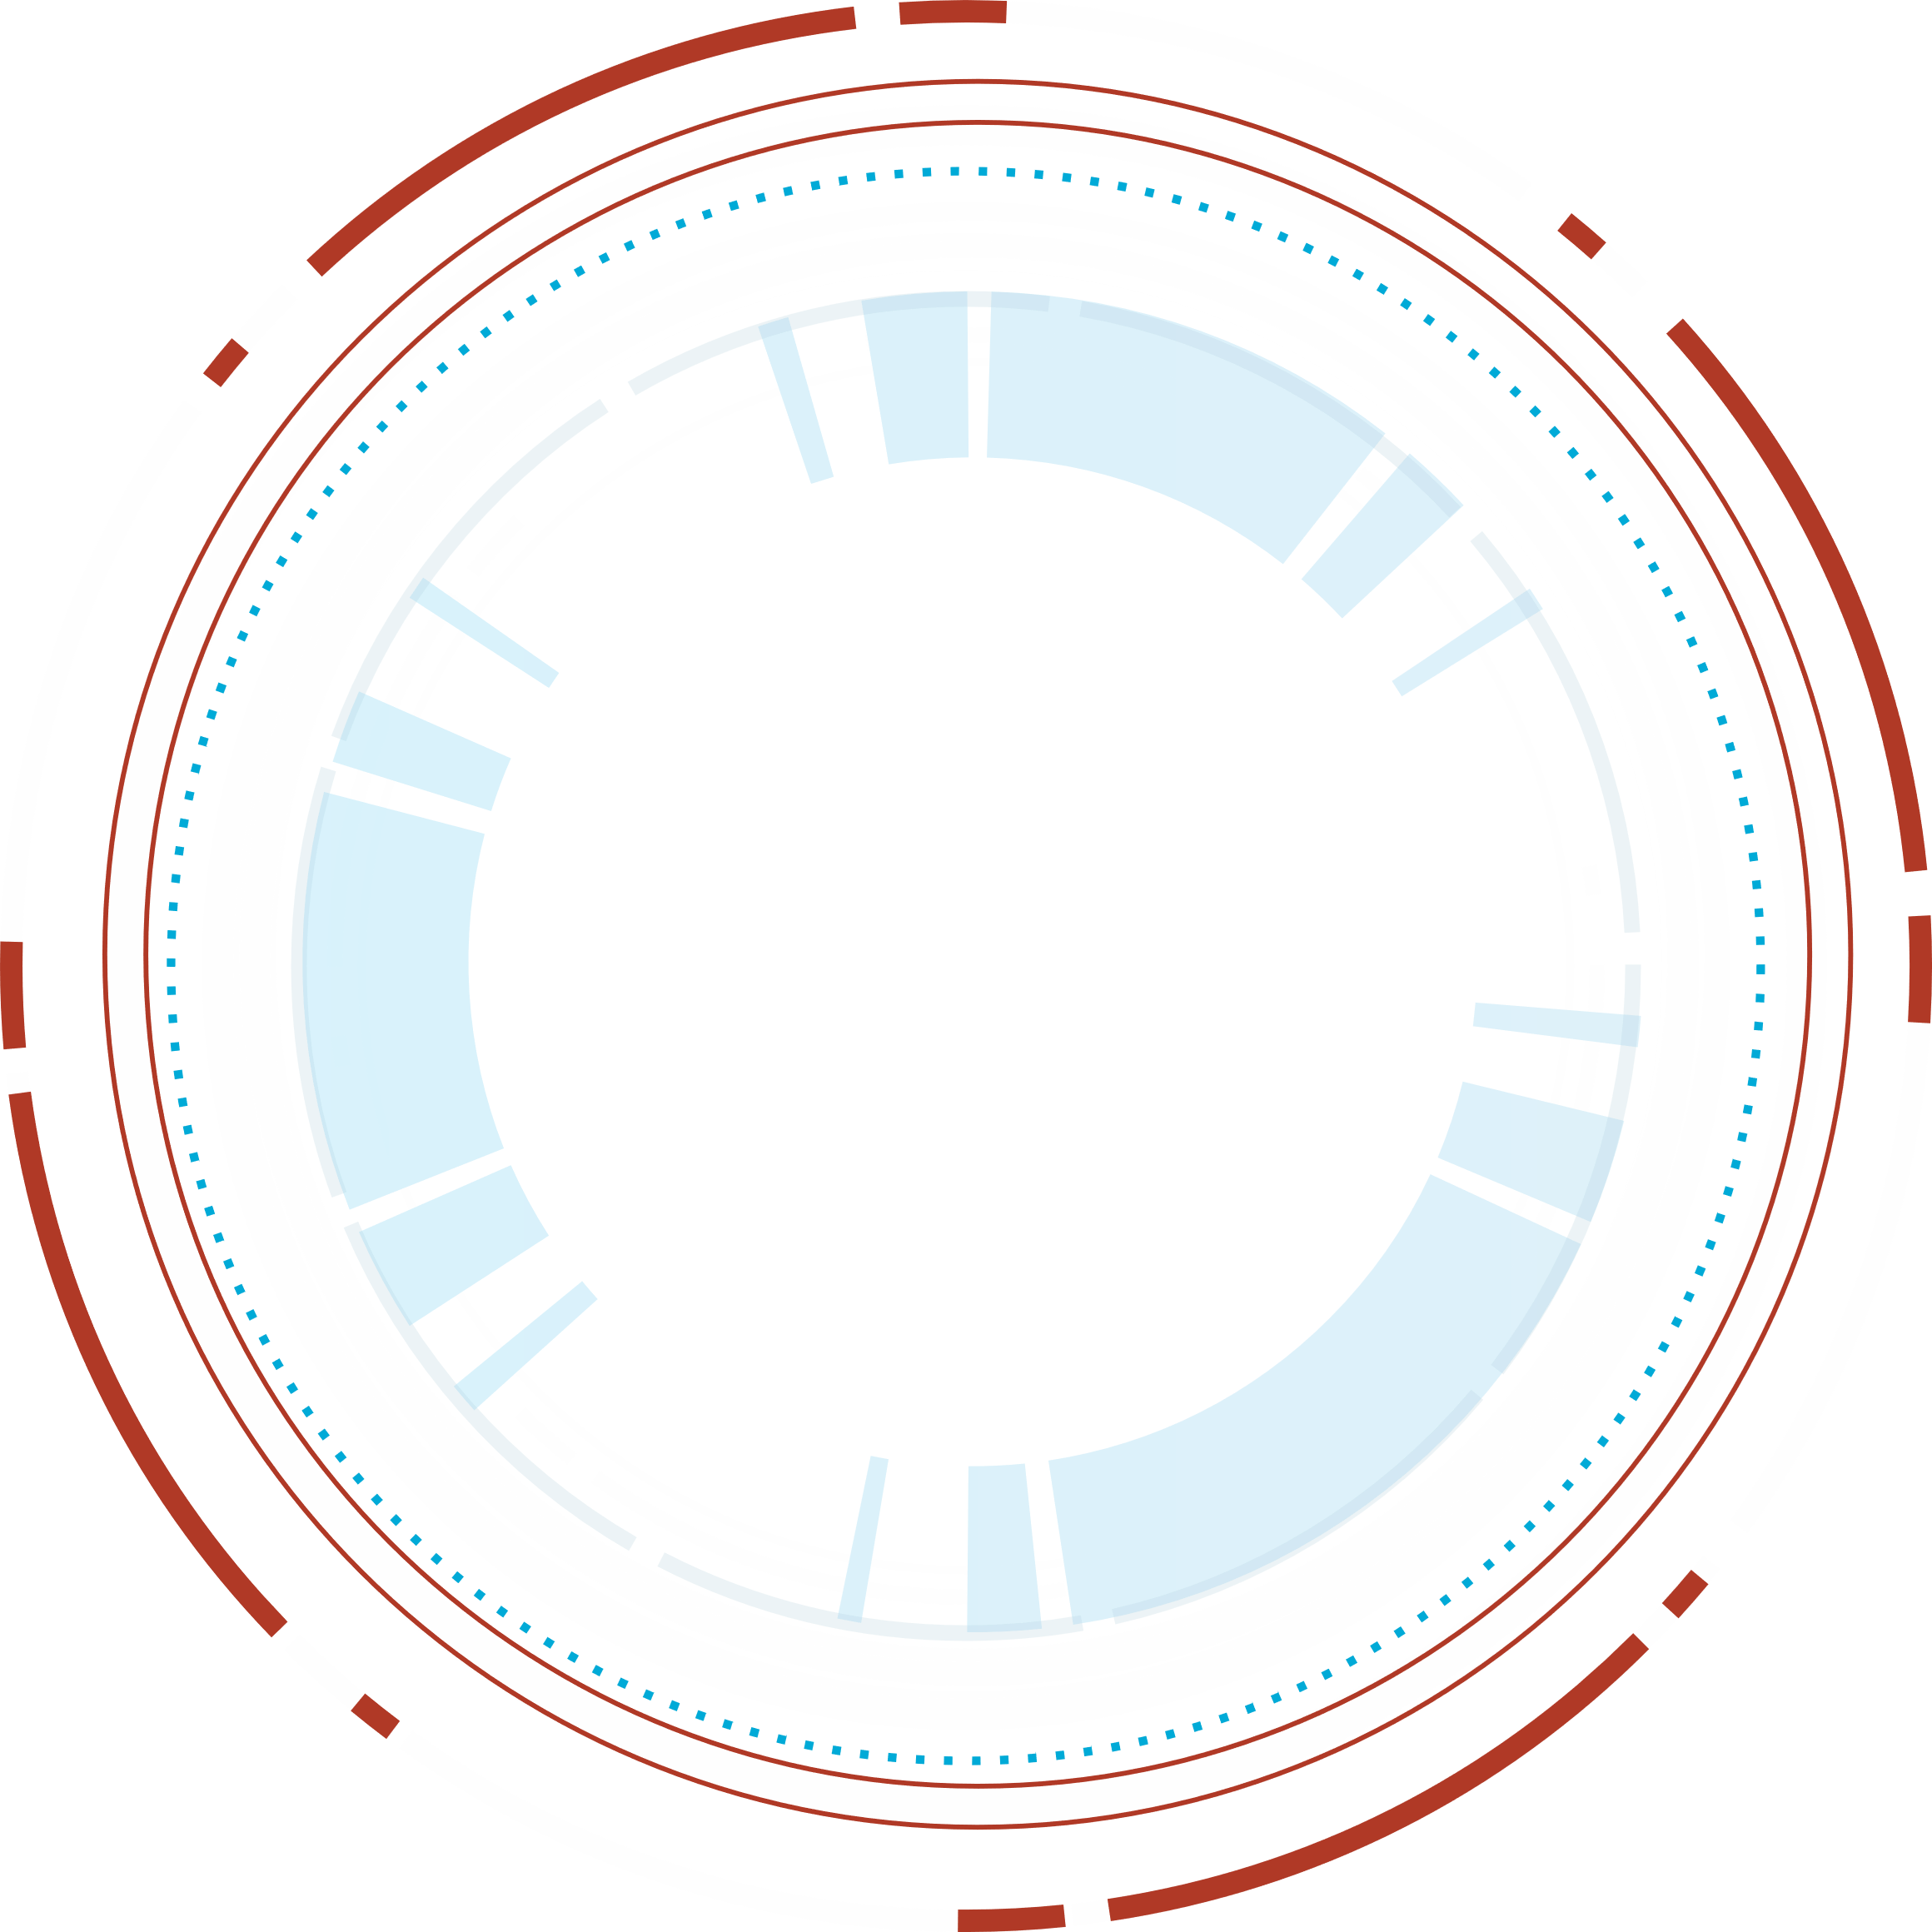




Sandia National Laboratories is a multimission laboratory managed and operated by National Technology & Engineering Solutions of Sandia, LLC, a wholly owned subsidiary of Honeywell International Inc., for the U.S. Department of Energy’s National Nuclear Security Administration under contract DE-NA0003525.

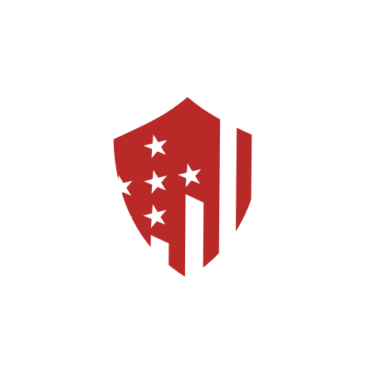
SNL SAND Number: SAND2026-19039W

SNL Visitor "Pre-Visit"
Security Checklist

  - Welcome to Sandia National Laboratories
  - March 24, 2026

SNL PRE-VISIT SECURITY CHECKLIST

Remember: OPSEC/COMMSEC/INFOSEC

Brief all visitors to Sandia National Laboratories:

Check | Important to Remember for the Scheduled Exercise (TA-V) Limited Area (LA)
 | Verify “all visitors” have been issued an SNL visitor’s badge. All visitors must display their SNL-issued badge above the waist and visible.
 | SNL Badges must be picked up at the Sandia Badge Office on the start date of the scheduled visit.
 | Unauthorized prohibited and controlled articles on Laboratory property may be confiscated by Sandia Pro-Force. Ref: external facing url https://www.sandia.gov/security
 | Visitors to SNL Limited Areas (LA) are “not allowed” to bring any mobile devices (MD) into the Limited Areas (LA).
 | Personal electronics such as mobile phones/Smart Watches/Ear Buds/Fitness Trackers, are considered prohibited articles in Limited Areas (LA), designated Secure Space and higher designated secure areas.
 | In Limited Areas (LA) or higher Medical Devices (MEDPEDs) must be pre-registered and approved prior to the scheduled visit. Ref: external facing url https://www.sandia.gov/security
 | Other Government Agencies (OGA) including DOE cleared visitors are included in the “no mobile devices” (i.e., Mobile phones). SNL has “no reciprocity policy” on mobile devices with Other Government Agencies (OGAs) and/or other National Laboratories. Visitors invited by Sandia Field Office (SFO) have reciprocity included in the Prime Contract.
 | Leave all unnecessary electronic devices at off-site location or stored in vehicle.
 | All Electronic Devices using Bluetooth and Wi-Fi must be disabled/turned off.
 | Uncleared (no DOE clearance) Visitors must be always escorted, within in the Limited Area (LA) and higher.
 | All unbadged visitors will be required to remain outside the Property Protection Areas (PPA), Limited Area (LA) and designated secure space.
 | Kirtland AFB (DOD) and Sandia National Laboratories (DOE) are federal institutions. They fall under Federal Law not State Law. Prohibited items include firearms, dangerous weapons, explosives, illegal drugs (including medicinal marijuana), drug paraphernalia, intoxicants such as alcohol and other items prohibited by law. Kirtland police perform mandatory spot checks on random vehicles with military K-9s.
 | Foreign National Visitors are only approved for access to certain buildings which are listed in their foreign national representative security plan (FNRSP).
 | All Incidents of Security Concern (IOSC) at SNL must be reported to SNL’s Security Incident Management Program (SIMP).

