Handout 4:
Quantifying Risks & Disaster Preparedness
Jack D. Flicker, Rachid Darbali-Zamora, and Jeewon Choi

How Are Disaster Risks Measured?
Microgrid designers use a severity scoring system to determine which disasters pose the greatest risks. Each hazard is rated based on:
✅ Impact on infrastructure – Minor, Moderate, Severe
✅ Likelihood of occurrence – Low, Medium, High

How Do Disasters Affect Microgrid Subsystems?
Disaster | Power Generation | Energy Storage | Controls/Communication
Flood | Medium/Moderate | High/Severe | High/Severe
Wildfire | Low/Moderate | Medium/Moderate | High/Severe
Hurricane | High/Severe | High/Severe | High/Severe
Earthquake | High/Severe | High/Severe | Medium/Moderate

Improving Disaster Resilience
✅ Use smart automation to manage disruptions
✅ Reinforce critical infrastructure against physical damage
✅ Integrate renewable energy for reliable power during crises


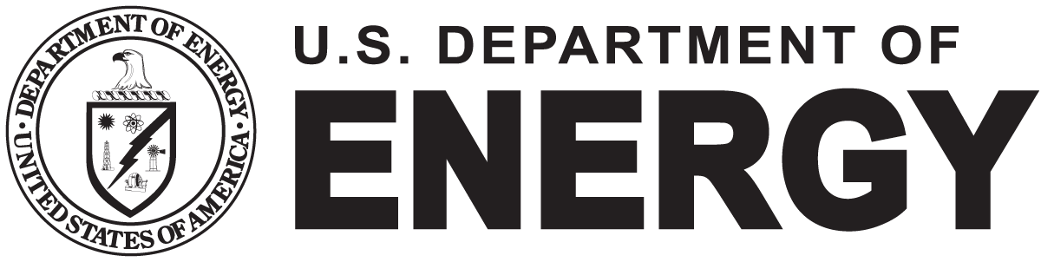
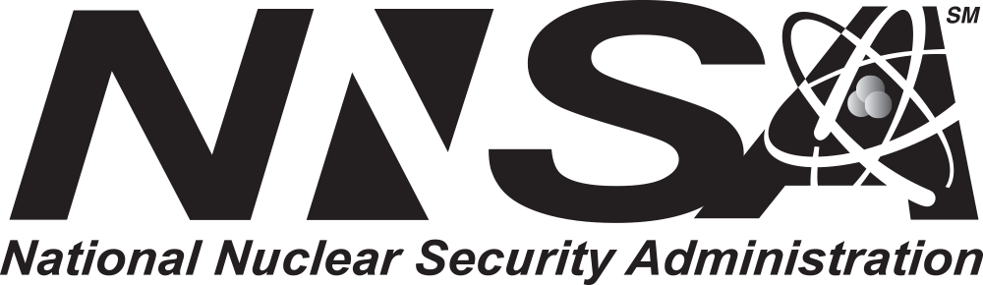
Sandia National Laboratories is a multimission laboratory managed and operated by National Technology & Engineering Solutions of Sandia, LLC, a wholly owned subsidiary of Honeywell International Inc., for the U.S. Department of Energy’s National Nuclear Security Administration under contract DE-NA0003525.

