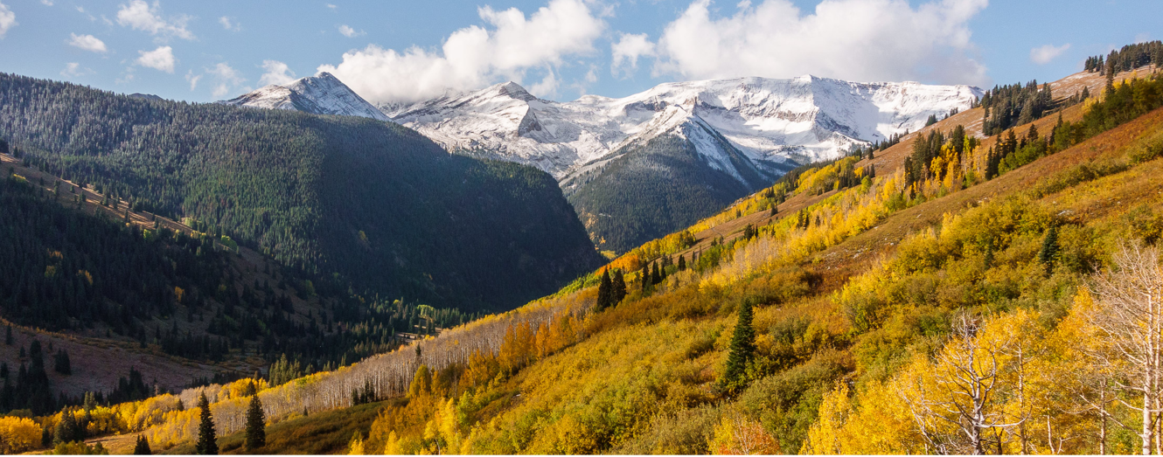

2025 APQC Schedule

Sunday, September 21st

Welcome Reception
6:00 - 8:00pm | Registration/Welcome Reception (Holiday Inn)

Monday, September 22nd

Scalable Performance Estimation
7:00 - 8:45am | Breakfast and Registration
8:45 - 9:00am | Welcome and Workshop Overview
9:00 - 10:00am | Senrui Chen, “Disambiguating Pauli noise in quantum computers” (invited)
10:00 – 10:30am | Alireza Seif, “On (non-)Markovianity of Paul channels”
10:30 - 11:15am | Coffee & collaboration break
11:15 - 11:45am | Jan Nöller, “Sound and SPAM-agnostic certification of quantum computation”
11:45am-12:15pm | Simon William, “Quantum Advantage in Resource Estimation”
12:15am - 1:45pm | Lunch (perspective talk by Clare Alloca, NIST Standards Coordination Office)
1:45 - 2:15pm | Ashe Miller, “Scalable gate set tomography with a linear error model”
2:15 - 2:45pm | Aniket Rath, “Benchmarking IQM's effective all-to-all quantum processor”
2:45 - 3:45pm | Coffee & collaboration break
3:45 - 4:45pm | , “Evaluating the performance of quantum processing units at large width and depth” (invited)
4:45 - 5:00pm | Poster session setup / free time
5:00 - 7:00pm | Poster session
7:00pm - | Dinner (on your own)

Tuesday, September 23rd

Logical qubit QCVV
7:00 - 8:30am | Breakfast
8:30 - 9:30am | Nathan Lacroix, “Scaling and logic in the color code on a superconducting quantum processor” (invited)
9:30 - 10:00am | Coffee break
10:00 - 10:45am | Jordan Hines, “Turning Characterization Results into Quantum Error Correction Predictions via Detector Error Models”
10:45 - 11:15am | Alex Kwiatkowski, “Constructing an approximate Markovian model of consecutive QEC cycles of a stabilizer code”
11:15 - 11:45am | Coffee break
11:45am - 12:15pm | Sohan Ghosh and Adeeb Kabir, “Logical Randomized Benchmarking a Qutrit Folded Code”
12:15 - 1:30pm | Lunch (including Lunch with an Expert)
1:30 - 2:30pm | David Hayes, “Benchmarking QCCD computers: from the physical to the logical layer” (invited)
2:30 - 3:00pm | Coffee break
3:00 - 3:30pm | Wim van Dam, “Physical and Logical Benchmarking with Random Clifford Circuits”
3:30 - 4:00pm | Jeremy Stevens, “Benchmarking Quantum Computers based on Cat-Qubits”
4:00 - 4:30pm | Matthew Girling, “Characterization of syndrome-dependent logical noise in detector regions”
4:30 - 4:45pm | Coffee break
4:45 – 5:45pm | Bence Hetenyi, “Characterization of logical Bell states on superconducting qubits” (invited)
5:45pm - | Dinner (on your own)

Wednesday, September 24th

Characterization and Control

7:00 - 8:30am | Grab & Go Breakfast (burritos & coffee)
8:30 - 2:45pm | Hiking/Collaboration Free Day
2:45 - 3:15pm | Coffee break
3:15 - 3:45pm | Jadwiga Wilkens, “Robust characterization of average gate set noise: Filtered randomized benchmarking and cross-talk tomography”
3:45 - 4:15pm | Bharath Hebbe Madhusudhana, “Error Detection in Quantum Sensing and Quantum Sensing Techniques for Error Detection”
4:15 - 4:45pm | Coffee Break
4:45 - 5:15pm | Alicia Magann, “Towards real-time quantum device calibration and drift mitigation”
5:15 - 5:45pm | Luke Burkhart, “Efficient and flexible execution of QCVV protocols in constrained control system environments
5:45 - 6:30pm | Free time
6:30 – 9:00pm | Banquet Dinner
7:30 – 8:45pm | Panel Debate

Thursday, September 25th

QCVV on Gates and Measurements

7:00 - 8:30am | Breakfast
9:00 - 10:00am | Piper Wysocki, “A hierarchical approach to understanding logical qubit performance” (invited)
10:00 - 10:45am | Coffee & collaboration break
10:45 - 11:15am | MengKe Feng, “Tomographic Study of Mid-Circuit Measurements in Silicon Spin Qubits”
11:15– 11:45am | John Paul Marceaux, “Subspace benchmarking with applications to entangling gates in ion traps”
11:45 - 1:15pm | Lunch (perspective talk by Alex Cronin, NSF)
1:15 - 2:15pm | Robin Harper, “Closing the Loop: Using Noise Characterization to Guide QEC Code Design” (invited)
2:15 - 2:45pm | Coffee break
2:45 - 3:15pm | Alan Tran, “Gate Set Tomography for Spin Qubits Encoded in a Decoherence-Free Subsystem”
3:15 - 3:45pm | Gian Giacomo Guerreschi, “QCVV Challenges for Exchange-Only Qubits in Silicon Quantum Dots”
3:45 - 4:00pm | Parting words
4:00pm | Adjourn

