Sandia.ecomedes.com User Guide

Sandia National Labs (Sandia) has a Prime Contract requirement flow-down from the Department of Energy (DOE) to track and report sustainable acquisitions provided by subcontractors. Sandia.ecomedes.com is a new Sustainable Acquisitions tracking and reporting tool, developed by ecomedes, to assist subcontractors with reporting the use of applicable products to Sandia. This tool allows for easier reporting and ensures compliance with existing requirements outlined in the SUSTAINABLE ACQUISITION AND AFFIRMATIVE PROCUREMENT - 350APR clause of Sandia subcontracts.

The 350APR clause states that a Subcontractor shall “provide its services in a manner that promotes the expanded use of green products, reduces greenhouse gas emissions and protects the health and wellbeing of building occupants, service providers and visitors in the facility.”

All applicable products/services shall strive to meet these applicable environmental specifications: environmentally sustainable, include recycled content per the EPA's CPG, include biobased content per USDA, be energy efficient (ENERGY STAR, FEMP and/or EPEAT), be water efficient (WaterSense), be fuel efficient (SmartWay), be non-ozone depleting (SNAP), be non-toxic or less-toxic than conventional alternatives (Safer Choice), and/or have an EPA Recommendations of Specifications, Standards, and Ecolabels.

This tool leverages GSA’s SFTool to identify which green purchasing requirements apply to the products and service you intend to buy, and allows you to:
- Utilize the catalog of products in this tool to identify items that meet the environmental specifications for items you may be required to report.
- Search for products you found elsewhere to check for compliance with the applicable specifications.
- Finally, if you cannot identify products, you will have the option of adding products, which may or may not meet required specifications. Adding your own products will require additional justifications.

Please create an account and generate reports by following the instructions below. If you have questions, please email purchasing@sandia.gov.

ACCOUNT CREATION & LOGIN

Create an Account – https://sandia.ecomedes.com/

- From the landing page, click Sign Up/Login in the top right of the page.
- If you don’t already have a login, click Sign Up at the bottom of Modal to create an account.
- Fill in all required fields and click continue.

Enter in Sign Up Code – https://sandia.ecomedes.com/profile (ZUSFPNDMA2TW8-subcon)

- After Sign Up or Login, you should be directed to the Profile page.
  - If you are not directed to the profile page, click your email in the top right and select Profile to be redirected.
- Enter in Sign Up Code (ZUSFPNDMA2TW8-subcon) for Access and click “Done.”
  - If you copy and paste the code, make sure there is not a space copied at the end. If this should happen, delete the space, and try again.
- The site will drop you back to the landing page - https://sandia.ecomedes.com/
  - If you are not directed to the landing page, click the Sandia logo in the top left to be redirected.
- You are now ready to search and save products!
- If you are having trouble, try logging out and then Login (again).
- Check results after entering valid User Id & Password.
- Login should be successful.

NOTE: In the future, once you have an ecomedes account just use the Login in boxes in the Modal window.

SEARCH – https://sandia.ecomedes.com/

To search in ecomedes use search filters on the left-hand side or use the keyword search at the top of the page.

- From the landing page, select from the filters on the left side of the page.
  - It is best to start by selecting the relevant Product Category for your search. Click on the title of the Product Category to select.
  - Choose a subcategory to narrow your search (e.g. Choose “Appliances” then “Commercial Ovens” Product Subcategory. Your selections will automatically display the relevant filters for the applicable Federal Requirements, and EPA Recommended Specifications, Standards, and Ecolabels that apply.
- Click the “+” buttons next to other left-hand filters, including Brand, Additional High-Performance Filters or CSI Division to open drop-down options. Click on or check the boxes of any that you wish to apply to refine your search.
- Remove any search filter by clicking the red, “X” button next to the filter name.
- Another option is to type a product name, SKU or keyword in the search box and click the magnifying glass or press enter.
  - Search results include only products that comply with at least one of the relevant Green Purchasing Requirements. If a SKU or brand name product fails to appear it is likely non-compliant. See the “Add a non-compliant to a Report product” section for information on how to track these.
- Results are filtered and displayed directly on the page. We will call this the search results page.

NOTE: Search items are all cumulative. If no results are returned, please broaden your search criteria.

CREATING A REPORT

Reports can be saved and will be marked as “In Progress,” which allows you to return and make edits as necessary. Once all applicable products have been added to a Report, it can be marked as “Purchased,” which locks the report., and define them. Users can use the tool to find compliant products, select those they intend to purchase and report those they have purchased for tracking purposes.

NOTE: Once you mark the Report as “Purchased,” you can no longer modify the products, prices, or quantities.

Add a compliant product from the catalog to a Report –

- Navigate to the top right of the homepage and click “Reports.”
- Click the blue “Create a Report” link to begin.
  - Type in the Project Name, Location (e.g., SNL/NM or SNL/CA), and Purchase Order ID.
- Once you have a Report created, you can begin searching for products through the product search bar and use left navigation for adding products into the report.
- From the Search results page, select the product you would like to add to a Report by clicking the image or Product name to navigate to a product page.
- From the product page, click the blue "Add to Report" button and select the Report you would like to add it to from the drop-down bar.
- Input the Quantity and Price for Sandia, then press “Submit.”
- By clicking “Submit”, the product, Price and Quantity is saved in your report.
- To view all your Reports, click “Reports” at the top of the screen.

Add a compliant product to a Report that is not in the catalog –

In some cases, where product registries don’t yet exist, compliant products need to be manually entered. This currently includes Recycled Content (EPA’s CPG) or products that do not have applicable Green Procurement rules (e.g. countertops).

- Navigate to the top right of the site and click “Report.”
- Click on the name of the Report to which you would like to manually add a product.
- Click the blue “+” button on the right-hand side of the page underneath the “Line Items.”
- Type the brand name, product name, product SKU, quantity, price for Sandia, and specify which compliance type with the compliance type drop down menu.
  - All fields are required to be filled out.
- Click the small blue check mark button the right-hand side of the product row to save it into your collection.

Add a non-compliant product to a Report –

- First, search the relevant Product Category page for compliant products. If none are found, then proceed to the following step.
  - Exemption justifications for providing non-compliant products are:
  - Cost (i.e., the cost of the compliant product exceeds 110% of the cost of the non-compliant product)
  - Availability (e.g., the compliant product is not available in time to meet a deadline)
  - Performance (e.g., the use of a compliant product may jeopardize the integrity of the process)
- Navigate to the top right of the site and click “Report.”
- Click on the name of the to which you would like to manually add a product.
- Click the blue “+” button on the left-hand side of the page underneath the “Line Items.”
- Type the brand name, product name, product SKU, quantity, price for Sandia, and specify which exempt justification type from the drop-down menu.
  - All fields are required to be filled out.
- Click the small blue check mark button the right-hand side of the product row to save it into your collection.

View your Reports –

- Make sure you are logged in.
- Select Reports on the top right of the page.
- Click on the name of the Report you want to edit or view.

NOTE: You have the capability to clone a Report, so you can save time when if you anticipate selling similar products in a future quarter.

View Rollup –

- Make sure you are logged in.
- Click Reports on the top right of the homepage to display your list of Reports.
- Click the Report name to view details.
- Click “Mark as Purchased” when you have completed the Report.
  - Note: You must mark a Report as” Purchased” for it to be included in the roll-up.
- Select the blue “View Rollup” button on the top right-hand side of the Reports page to see a Federal Statute Summary of your Reports.
  - The “Rollup” will show which products comply with requirements, such as Water Sense, Energy Star, Biopreferred, etc.
  - The Rollup will also show you products that have no certifications attached to them.

Generate PDF of Report –

- Click Reports Tab in the top left-hand corner on the Repots page.
- Select a Report that has already been marked as "Purchased."
- NOTE: A report can be blank/ contain no products, but it must be marked as purchased to generate a PDF.
  - If you have the 350APR clause in your contract, you will be required to submit a report each FYQ. If you do not sell applicable products in an FYQ, you will be required to submit a blank report.
- Select the "Print PDF" button in the top right corner of the reports page.
- This will prompt your browser to pop up with a screen as if it is going to print the document. Set the Destination as "Save As PDF" and click Save.
- You now have a PDF version of the document to submit with your invoice to Sandia.

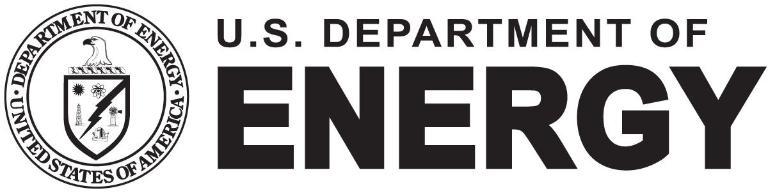
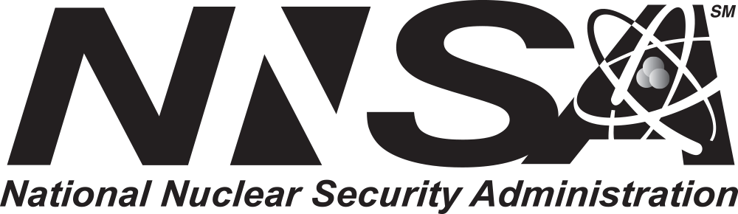
General Rule of Thumb –
Sandia National Laboratories is a multimission laboratory managed and operated by National Technology & Engineering Solutions of Sandia, LLC, a wholly owned subsidiary of Honeywell International Inc., for the U.S. Department of Energy’s National Nuclear Security Administration under contract DE-NA0003525.
SAND2021-15774 TR

- If the system or webpage appears to be non-responsive, hit F5 or the refresh icon to reload the page.

